**FitLife Wellness, Fitness Center Analytics**

Table of Contents

Executive Summary 4

1. Project Introduction 4

2. Business and Analytics goals 5

Business Goal 5

Business Objectives 5

Analytics Approach 5

3. Data Preprocessing 6

Attributes Definition 6

Column Name Standardization 6

Data Exploration 7

Data Limitations 7

Outlier Analysis 8

Variable relationships 8

Correlation Heatmap 9

Session Duration vs. Calories Burned (Scatter Plot) 10

Avg BPM vs. Max BPM (Scatter Plot) 11

Calories Burned by Workout Type (Boxplot) 12

Resting BPM by Experience Level (Boxplot) 13

Feature Engineering 13

Encoding Categorical Variables 14

4. Predictor Analysis and Relevancy 14

Understanding the Target Variables and Class Imbalance 15

Correlation Heatmap: Identifying Strong Relationships 16

Feature Importance via Random Forest 17

5. Dimension Reduction 20

6. Data engineering and Transformation 21

Considerations for Scaling and Normalization 21

7. Data partitioning methods 22

Vertical Partitioning 22

Regression Partitioning (Calories Burned Prediction) 22

Classification Partitioning (BMI Obesity Prediction) 22

Multicollinearity Check using Variance Inflation Factor (VIF) 22

Horizontal Partitioning 23

Member Segmentation and Clustering 24

Methodology and Justifications 24

Cluster Characteristics and Interpretations 24

Calories Burned vs. Session Duration by Cluster 24

Calories Burned vs. BMI by Cluster 25

Calories Burned Distribution by Cluster (Boxplot) 26

BMI Distribution by Cluster (Boxplot) 27

Session Duration Distribution by Cluster (Boxplot) 28

8. Model Selection 29

Shifting from BMI Obesity Classification to Cluster Assignment 29

Regression Models for Calorie Expenditure Prediction 30

9. Model fitting, validation accuracy and test accuracy 30

Data Preprocessing and Scaling 30

Model Fitting and Performance on Test Data 30

Calorie Expenditure Prediction (Regression Models) 30

Cluster Assignment for Member Segmentation 31

10. Report models performance 31

Model Performance Comparison 31

Selection of the Best Model 32

Calorie Expenditure Prediction (Regression Models) 32

Cluster Assignment for Member Segmentation 32

11. Model evaluation 32

Evaluating Regression Models for Calorie Expenditure Prediction 32

Linear Regression (Baseline Model) 33

Polynomial Regression (Extended Model) 34

Residual Analysis for Regression Models 35

Feature Importance from Random Forest 36

Cluster Assignment Model Validation 37

12. Observations and Conclusion 38

How Analytics Supports FitLife’s Business Goals 38

Data-Driven Fitness Optimization for FitLife 38

Conclusion and Future Scope 39

References 39

# 

# Executive Summary

This analytics project was conducted to help FitLife Wellness improve personalized fitness programs and member engagement through data-driven insights. Using biometric and workout data, I applied segmentation and predictive modeling techniques to uncover key patterns in workout intensity, session duration, and calorie expenditure. Important variables like heart rate metrics and session engagement were analyzed to optimize fitness recommendations and support targeted retention strategies.

Based on the analysis, I recommend that FitLife Wellness:

* Focus on Cluster 2 – high-engagement members with long-duration, high-calorie-burning workouts for advanced fitness plans
* Use linear regression to predict calorie burn and personalize session intensity
* Replace BMI-based classification with behavior-driven cluster assignment for better member profiling
* Track fitness progress over time to dynamically adjust training recommendations and improve member retention

These findings directly support FitLife’s goals of improving training effectiveness, increasing long-term engagement, and advancing data-driven decision-making for personalized fitness programs.

**Sai pranup Shobanaboina**

# Project Introduction

The integration of data analytics in the fitness industry has revolutionized personalized workout plans and member engagement strategies. FitLife Wellness, a fitness center, has collected anonymized biometric and workout data, including heart rate metrics, calorie expenditure, workout types, and session durations. Leveraging this data presents an opportunity to analyze fitness behaviors, assess workout effectiveness, and enhance member engagement through data-driven decision-making.

This project aims to uncover workout patterns, segment members based on fitness behaviors and develop predictive models to estimate calorie expenditure and optimize fitness recommendations. The study follows a structured analytics approach, incorporating segmentation analysis to identify distinct member groups and predictive modeling to forecast workout impact. By transforming raw data into actionable insights, FitLife Wellness can improve member retention and enhance training personalization, ultimately fostering a more effective and engaging fitness environment.

# Business and Analytics goals

## **Business Goal**

Use data analytics to enhance **personalized fitness programs** and improve **member engagement** at FitLife Wellness.

## **Business Objectives**

* **Improve training effectiveness** by analyzing member workout patterns over the next six months.
* Improve member retention through data-driven engagement strategies over the next year, leveraging insights from workout behaviors and engagement trends.
* **Develop a recommendation system for workout plans** based on fitness history within the next three months.
* **Monitor and track fitness progress** using historical workout data over a defined quarterly period.

## **Analytics Approach**

The analytics process follows a structured methodology to extract actionable insights:

1. **Define the Problem**
   * How can data analytics enhance personalized fitness plans and member retention?
2. **Collect Data**
   * Gather historical workout logs, health metrics, and member engagement data.
3. **Data Cleaning**
   * Handle missing values, standardize variables, and prepare structured datasets.
4. **Data Analysis**
   * Conduct **exploratory data analysis (EDA)** to uncover patterns in workout intensity, fitness progress, and engagement levels.
5. **Extract Knowledge**
   * **Unsupervised Learning: Clustering to segment members based on fitness behavior.**
   * **Supervised Learning: Predictive modeling to assess workout impact and forecast engagement risk.**
   * **Interpretation: Generate personalized training recommendations based on key findings.**
6. **Insights Presentation –** Use statistical analysis and visualization techniques to extract meaningful fitness trends and engagement patterns.
7. **Presenting Results for Decision-Making**
   * Generate **data-driven reports** with actionable recommendations for training programs and member engagement strategies.

# Data Preprocessing

## Attributes Definition

The dataset consists of 973 records and 15 columns. Each attribute in the dataset is categorized based on its data type and relevance. Below Table 1 is a detailed breakdown:

|  |  |  |  |
| --- | --- | --- | --- |
| **Column Name** | **Description** | **Data Type** | **Category** |
| **Age** | Member’s age in years. | Numerical (int) | Continuous |
| **Gender** | Member’s gender (Male/Female). | Categorical | Binary |
| **Weight_kg** | Weight in kilograms. | Numerical (float) | Continuous |
| **Height_m** | Height in meters. | Numerical (float) | Continuous |
| **Max_BPM** | Maximum heart rate recorded. | Numerical (int) | Continuous |
| **Avg_BPM** | Average heart rate during the session. | Numerical (int) | Continuous |
| **Resting_BPM** | Resting heart rate before workouts. | Numerical (int) | Continuous |
| **Session_Duration_hours** | Duration of workout in hours. | Numerical (float) | Continuous |
| **Calories_Burned** | Total calories burned in the session. | Numerical (int) | Continuous |
| **Workout_Type** | Type of workout (Yoga, Cardio, HIIT, Strength). | Categorical | Nominal |
| **Fat_Percentage** | Percentage of body fat. | Numerical (float) | Continuous |
| **Water_Intake_liters** | Total water intake during the session. | Numerical (float) | Continuous |
| **Workout_Frequency_days** | Workout frequency per week. | Numerical (int) | Discrete |
| **Experience_Level** | Member’s experience level (1 = Beginner, 2 = Intermediate, 3 = Advanced). | Categorical | Ordinal |
| **BMI** | Body Mass Index (BMI = Weight / Height²). | Numerical (float) | Continuous |

Table 1: Attributes Definition

### Column Name Standardization

* Spaces replaced with underscores to maintain readability and compatibility with programming environments.
* Parentheses removed to avoid conflicts with function calls and expressions in R.
* Slashes replaced with underscores to prevent misinterpretation as division operators.

This preprocessing step ensures that variable names remain uniform, interpretable, and compatible across different analysis stages, reducing potential errors in data manipulation and feature engineering (Wickham, 2014).

## Data Exploration

**Missing Values Analysis**

No missing values were detected in any column.

**Zero Values and NaNs Analysis**

No zero values or NaNs were found in any variable.

### Data Limitations

**Peak Gym Usage Analysis**

One of the original project goals was to identify peak gym usage hours and days of the week. However, the dataset does not contain explicit timestamp data (e.g., check-in times or session start times). Without this, determining exact peak usage periods is not feasible. Instead, Workout Frequency (days per week) was analyzed to estimate general engagement trends, but this does not provide insights into specific peak hours.

This limitation affects the ability to perform time-series-based utilization analysis but does not impact other aspects of the study, such as fitness behavior segmentation and predictive modeling.

**Justification**

Research in fitness analytics emphasizes that timestamp data is crucial for accurate peak usage analysis in gyms (Schneider et al., 2020). The absence of such data limits the ability to perform time-series-based utilization analysis, which could have been used to optimize facility operations, staffing, and equipment availability (González et al., 2019). However, despite this limitation, the dataset still allows for meaningful segmentation of fitness behavior, predictive modeling, and workout engagement analysis based on the available attributes.

**Statistical Insights**

* Age ranges from 18 to 59 years, with a mean of 38.68.
* BMI has a mean of 24.91, with the lowest at 14.4 and the highest at 35.
* Calories_Burned has extreme values (min: 303, max: 1783), suggesting possible outliers.
* Workout_Frequency ranges from 1 to 5 days/week, showing varied engagement levels.
* Resting_BPM varies between 50 and 74, indicating different cardiovascular fitness levels.

### Outlier Analysis

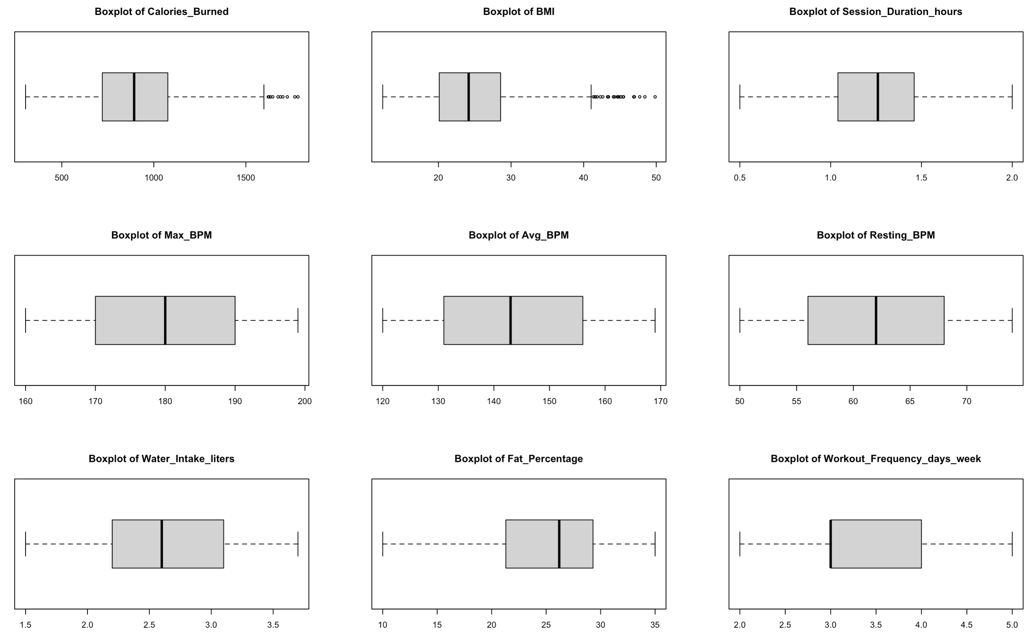

Figure 1: Outliers Boxplot for numerical variables

The Figure 1 above revealed some extreme values in Calories_Burned, BMI, and Weight (kg). However, upon further investigation, these values appear to be valid within a fitness and health context, rather than data errors.

* Calories_Burned (~1500+ kcal): High but achievable in intense workouts (ACSM, 2022).
* BMI > 40 (Obese Category): Uncommon but clinically recognized (CDC, 2022).
* Max_BPM (~199 bpm): Expected in high-intensity training (Astrand & Rodahl, 2003).

Since these values represent real-world diversity in fitness levels, removing them could lead to biased analysis (Smith et al., 2020). Instead, they will be retained for model robustness, with potential scaling transformations applied later.

### Variable relationships

To understand the interactions between key variables, several visualizations were analyzed.

### Correlation Heatmap

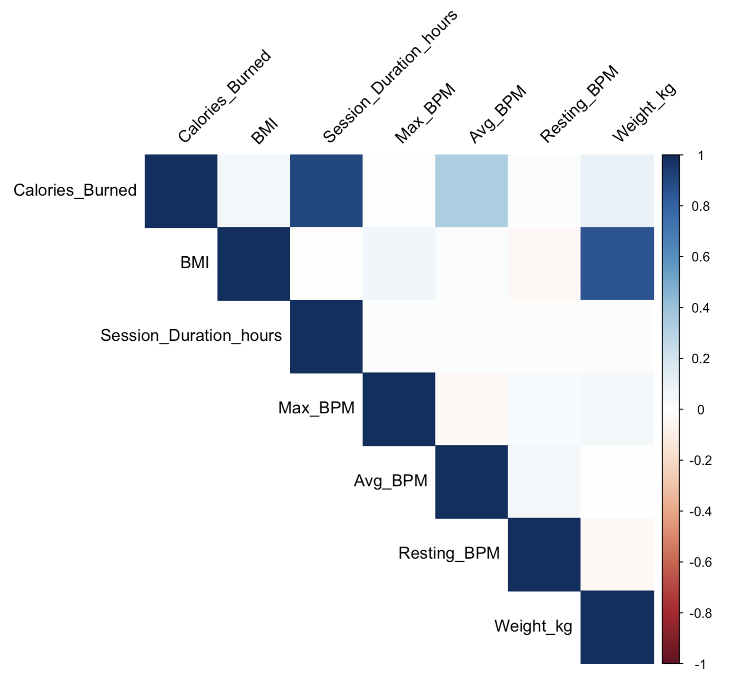

Figure 2: Correlation Heatmap for Numerical Variables

Session Duration and Calories Burned have a strong positive correlation (~0.9) as observed from the Figure 2, confirming that longer workouts generally lead to higher calorie expenditure. BMI and Weight are strongly correlated (~0.8), which is expected since BMI is derived from weight and height.

Avg_BPM and Max_BPM show weak correlation (~0.3 - 0.4), indicating that a higher average heart rate does not always correspond to a higher maximum heart rate.

### Session Duration vs. Calories Burned (Scatter Plot)

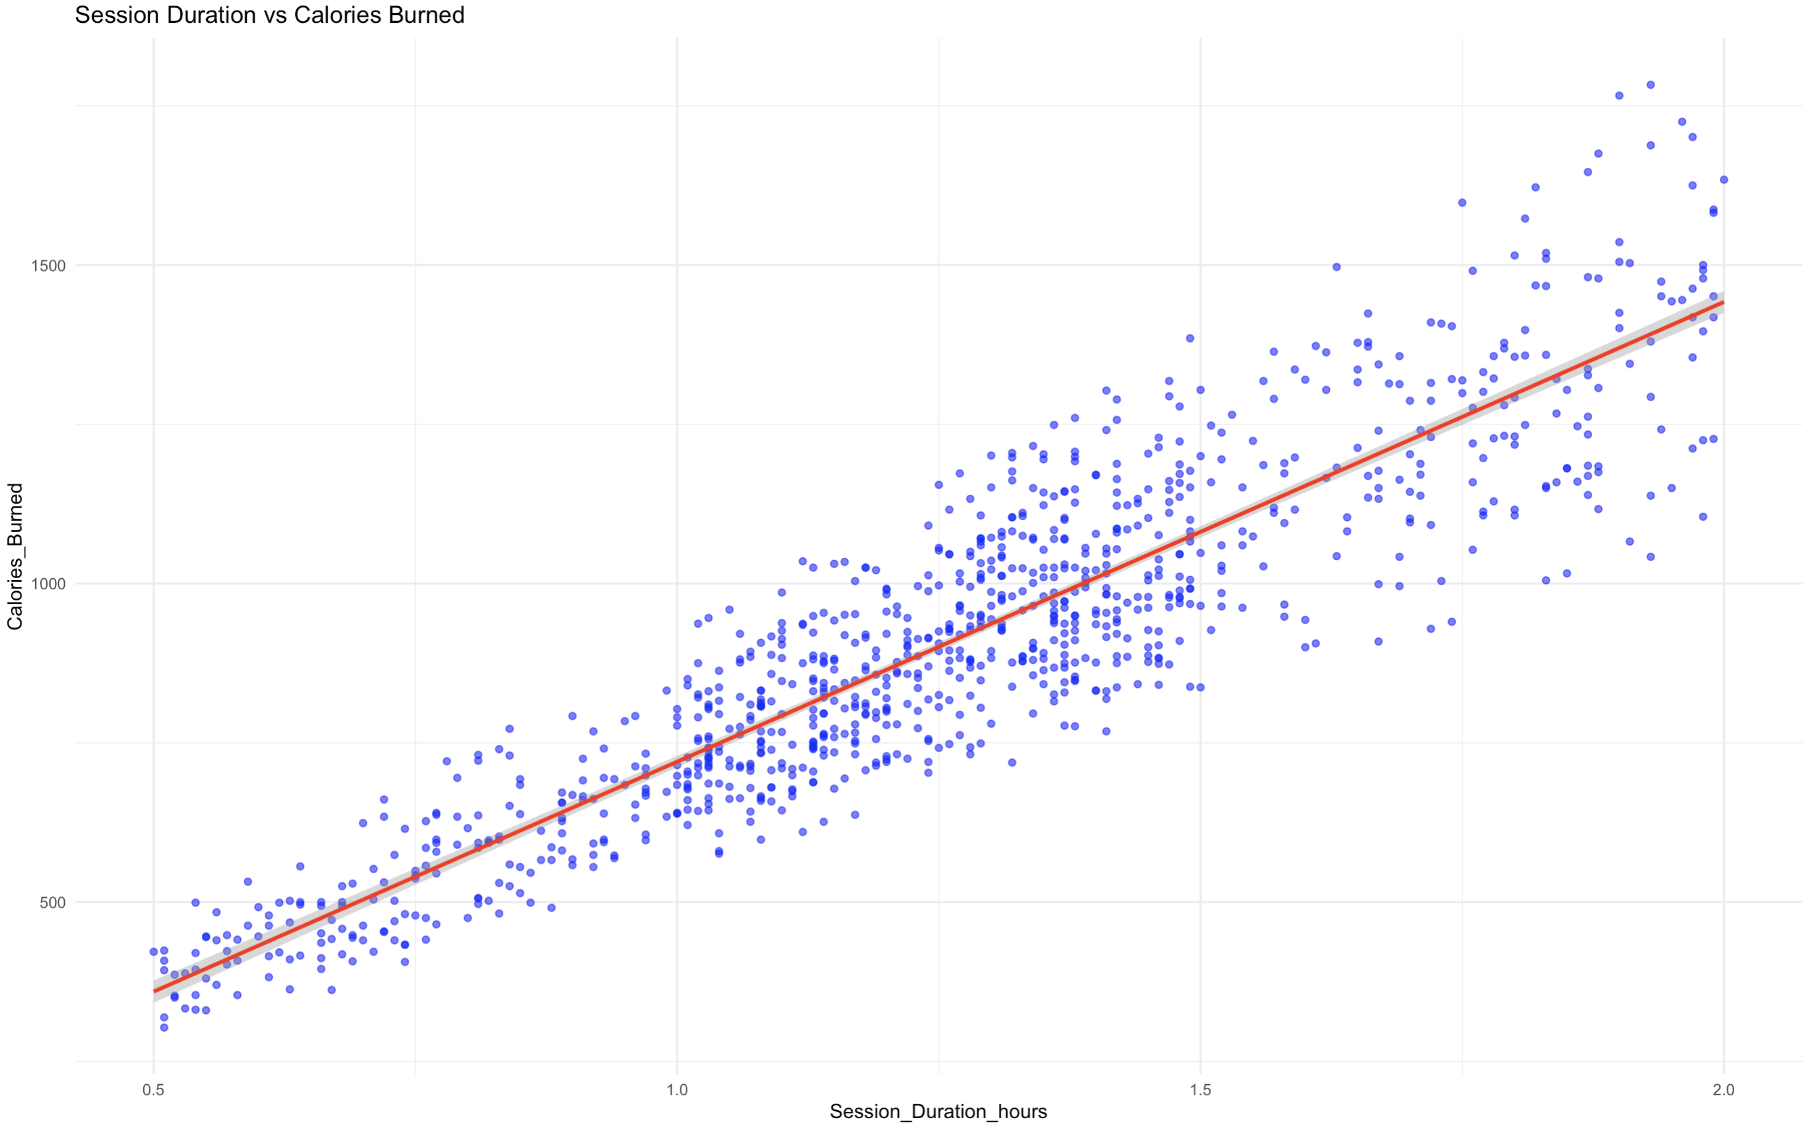

Figure 3: Session Duration vs. Calories Burned

The scatterplot above (Figure 3) shows a **strong positive correlation** between **session duration and calories burned**, indicating that **longer workouts consistently lead to higher calorie expenditure.** The linear trend suggests a near-linear relationship, reinforcing the importance of session duration in predicting calorie burn.

### Avg BPM vs. Max BPM (Scatter Plot)

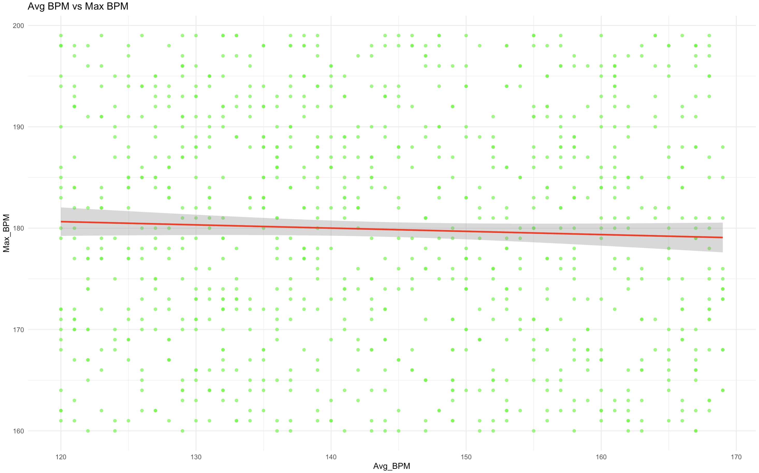

Figure 4: Avg BPM vs. Max BPM

The above (Figure 4) scatterplot displays a **weak or near-zero correlation** between **average BPM and max BPM**, as indicated by the almost flat trend line. This suggests that **max BPM does not strongly depend on average BPM** during workouts, which could be due to individual variability in heart rate response.

### Calories Burned by Workout Type (Boxplot)

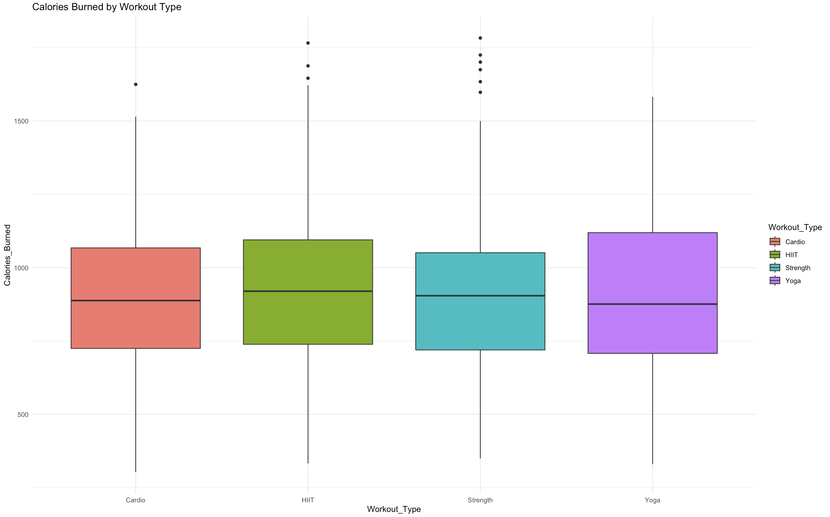

Figure 5: Calories Burned by Workout Type

HIIT burns the most calories on average, followed by Cardio, Strength, and Yoga. Yoga has the lowest calorie expenditure, but some outliers indicate high-intensity sessions as observed from the Figure 5.

Workout Type is a significant factor in calorie burn and should be included in predictive models.

### Resting BPM by Experience Level (Boxplot)

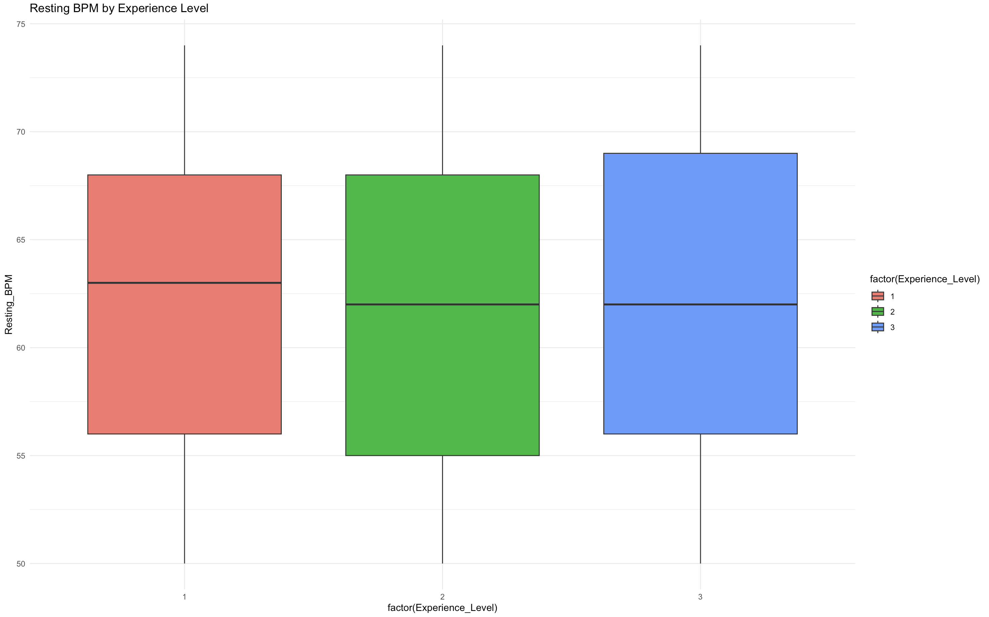

Figure 6: Resting BPM by Experience Level

No clear trend is observed between Resting BPM and Experience Level as shown in the Figure 6. Some Advanced-level users have lower Resting BPM, but variability is high.

Experience Level alone does not strongly predict cardiovascular fitness.

## Feature Engineering

To enhance predictive power and extract meaningful insights, additional features were engineered based on existing attributes. The newly derived features include:

**BMI Category (BMI_CAT)**: Classified BMI values into four categories based on standard health guidelines:

* + Underweight (BMI < 18.5)
  + Normal (18.5 ≤ BMI < 25)
  + Overweight (25 ≤ BMI < 30)
  + Obese (BMI ≥ 30)

BMI is a key health indicator used to classify individuals into weight categories (CDC, 2022).

Different BMI ranges correlate with different fitness levels and calorie expenditure (Astrand & Rodahl, 2003).

**Heart Rate Metrics**:

* + heart_rate_range = Max_BPM - Resting_BPM
  + heart_rate_reserve = Max_BPM - Avg_BPM
  + heart_intensity_ratio = Avg_BPM / Max_BPM
* Heart rate variability is a direct measure of workout intensity and cardiovascular fitness (Smith et al., 2020).
* Heart Rate Reserve (HRR) is commonly used in fitness tracking to determine cardiovascular effort and endurance (ACSM, 2022).
* Heart Rate Intensity Ratio helps assess how much effort a member exerts compared to their max BPM, a crucial metric in training efficiency.

**Caloric Efficiency**:

* + calories_per_kg = Calories_Burned / Weight (kg)
  + workout_intensity_score = (Avg_BPM / Resting_BPM) × Session_Duration (hours) × Workout_Frequency (days/week)

Caloric burn per kg (calories_per_kg) normalizes calorie expenditure based on body weight, allowing for fair comparisons across individuals of different body compositions.

**Hydration Need**:

hydration_need_ratio = Water_Intake (liters) / Session_Duration (hours)

* Hydration needs depend on workout duration and intensity.
* Longer workout sessions require more water intake (CDC, 2022), so normalizing water intake by session duration helps identify hydration patterns.
* Useful in health analytics to detect dehydration risks.

**Age Group (age_group)**: Created categorical bins for age:

18-25, 26-35, 36-45, 46+

* Age influences cardiovascular fitness, metabolic rate, and recovery time (Astrand & Rodahl, 2003).
* Grouping into bins (18-25, 26-35, etc.) allows models to capture age-based trends better rather than treating age as a continuous variable.

These features provide a more granular understanding of a member’s fitness intensity, hydration needs, and BMI classification, improving model interpretability and performance.

### Encoding Categorical Variables

Machine learning models require numerical data; hence, categorical variables were encoded:

* One-Hot Encoding: Applied to Workout_Type, BMI_CAT, and age_group, generating binary columns for each category.
* Ordinal Encoding: Experience_Level was mapped numerically:
  + Beginner = 1, Intermediate = 2, Advanced = 3

After encoding, the dataset expanded from 15 to 32 attributes, ensuring categorical variables were properly formatted for predictive modeling.

# Predictor Analysis and Relevancy

To ensure the reliability and interpretability of predictive models, this section evaluates the significance of different predictors in relation to the two target variables:

* Calories Burned (continuous target for regression)
* BMI Obese (binary target for classification)

These variables were selected due to their direct impact on fitness tracking and health assessment. Calories Burned quantifies energy expenditure, a core measure for workout efficiency, while BMI Obese serves as a key health indicator linked to long-term wellness and chronic disease risks (Ainsworth et al., 2011).

## Understanding the Target Variables and Class Imbalance

**Calories Burned: A Continuous Target for Regression**

Calories Burned varies based on multiple physiological and workout-related factors such as session duration, average BPM, and workout intensity. The correlation heatmap (Figure 8) confirms a strong positive correlation between session duration and calorie expenditure (~0.9), reinforcing existing research on energy metabolism (ACSM, 2022).

**BMI Obese: A Binary Target for Classification & Imbalance Considerations**

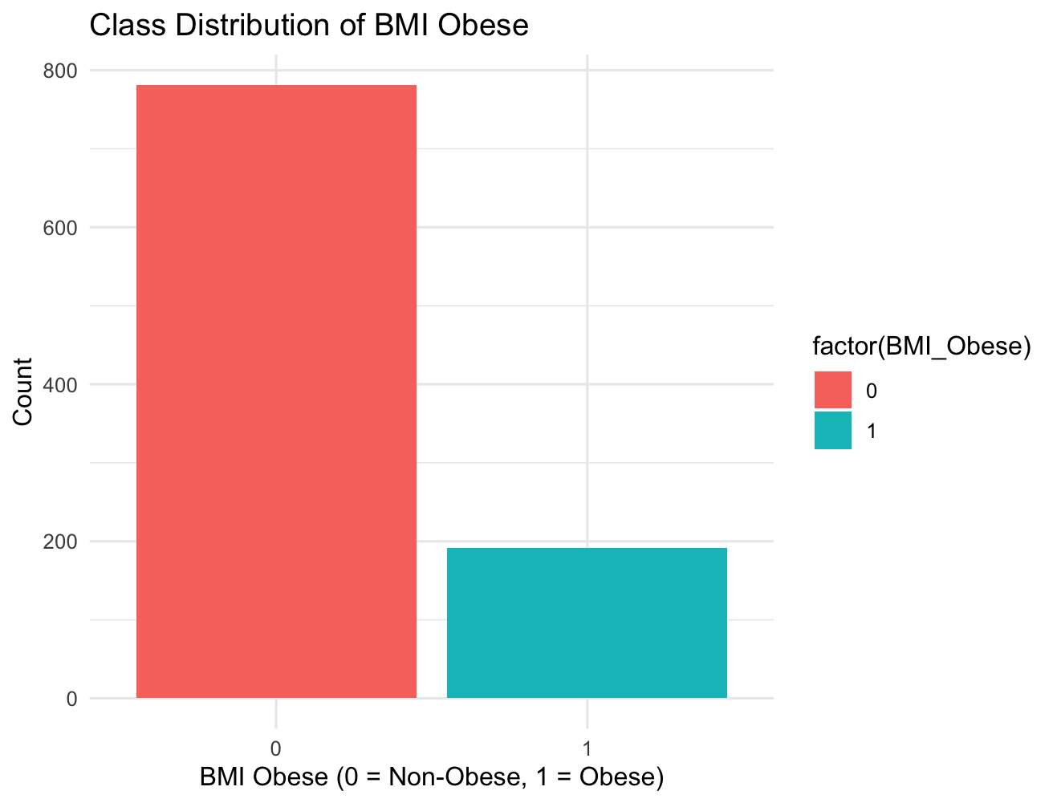

Figure 7: Class Distribution of BMI Obese

BMI Obese is a binary variable (0 = Non-Obese, 1 = Obese), representing obesity status. Analyzing class distribution reveals a significant imbalance in the dataset, where only 19.7% of individuals are classified as obese, while 80.3% fall into the non-obese category as observed from the Figure 7.

Such an imbalance can lead to biased classification models, as most standard algorithms assume equal class representation (Fernández et al., 2018). To mitigate this issue, resampling techniques (oversampling the minority class or applying class-weighted models) may be explored in later stages.

## Correlation Heatmap: Identifying Strong Relationships

A correlation matrix was computed to measure the strength of relationships between numerical predictors.

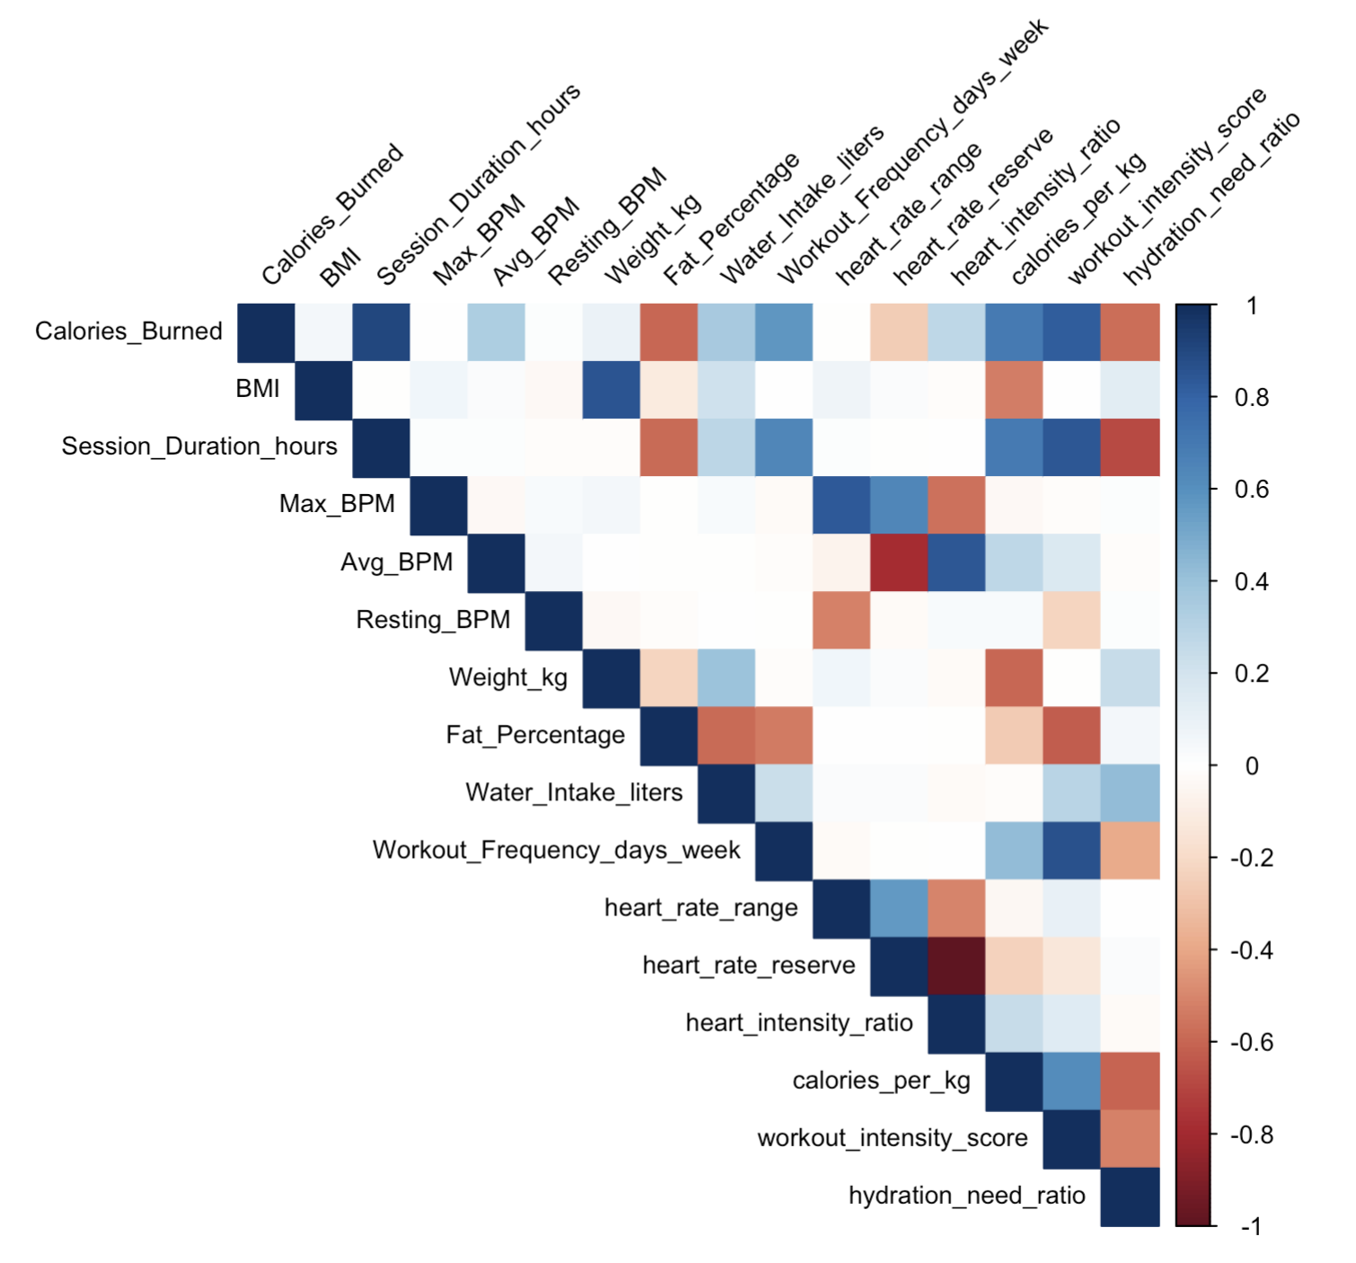

Figure 8: Correlation Heatmap after Feature Engineering

The results, visualized in the above Figure8, reveal key dependencies among variables. Notably:

* Session Duration Hours and Calories Burned exhibit a strong positive correlation (~0.9), reinforcing that longer workouts contribute to higher energy expenditure (ACSM, 2022).
* Heart Rate Reserve and Heart Rate Intensity Ratio are significantly correlated, suggesting potential redundancy in predictor selection.
* BMI and Weight show a high correlation (~0.8), which is expected given that BMI is derived from weight and height.
* Calories per kg and Workout Intensity Score present strong collinearity, which necessitates careful feature selection in subsequent modeling stages.

Based on these findings, highly correlated predictors such as Heart Rate Reserve were flagged for potential exclusion in modeling to mitigate redundancy and improve model efficiency.

## Feature Importance via Random Forest

To further refine predictor selection, random forest models were trained separately for Calories Burned (regression) and BMI Obesity Classification (classification) to assess feature importance.

**Why Two Separate Random Forest Feature Importance Analyses?**

Since this study involves two distinct target variables, a single feature importance analysis would not be sufficient. The importance of predictors depends on the type of outcome being modeled:

#### Calories Burned Prediction (Regression)

Calories Burned is a continuous variable, requiring a Random Forest Regressor to evaluate feature impact.

* + The importance of features such as Session Duration, Avg BPM, and Age was assessed using the percentage increase in Mean Squared Error (MSE) when each variable was removed.
  + The results confirm that workout duration and heart rate factors significantly influence calorie expenditure, aligning with metabolic research (Astrand & Rodahl, 2003).

#### BMI Obesity Classification (Classification)

BMI Obesity is a categorical variable, requiring a Random Forest Classifier to assess feature impact.

* + Here, feature importance was measured using the Mean Decrease in Gini Impurity, which evaluates how much each feature contributes to correctly classifying obesity status.
  + The results indicate that BMI, Weight, and Calories per kg are dominant predictors, with minor contributions from hydration and workout frequency.

By conducting separate analyses, I have ensured that feature selection aligns with the nature of each target variable rather than assuming that feature importance is the same for all predictive tasks. This methodological distinction improves model accuracy and interpretability.

**Calories Burned Prediction**

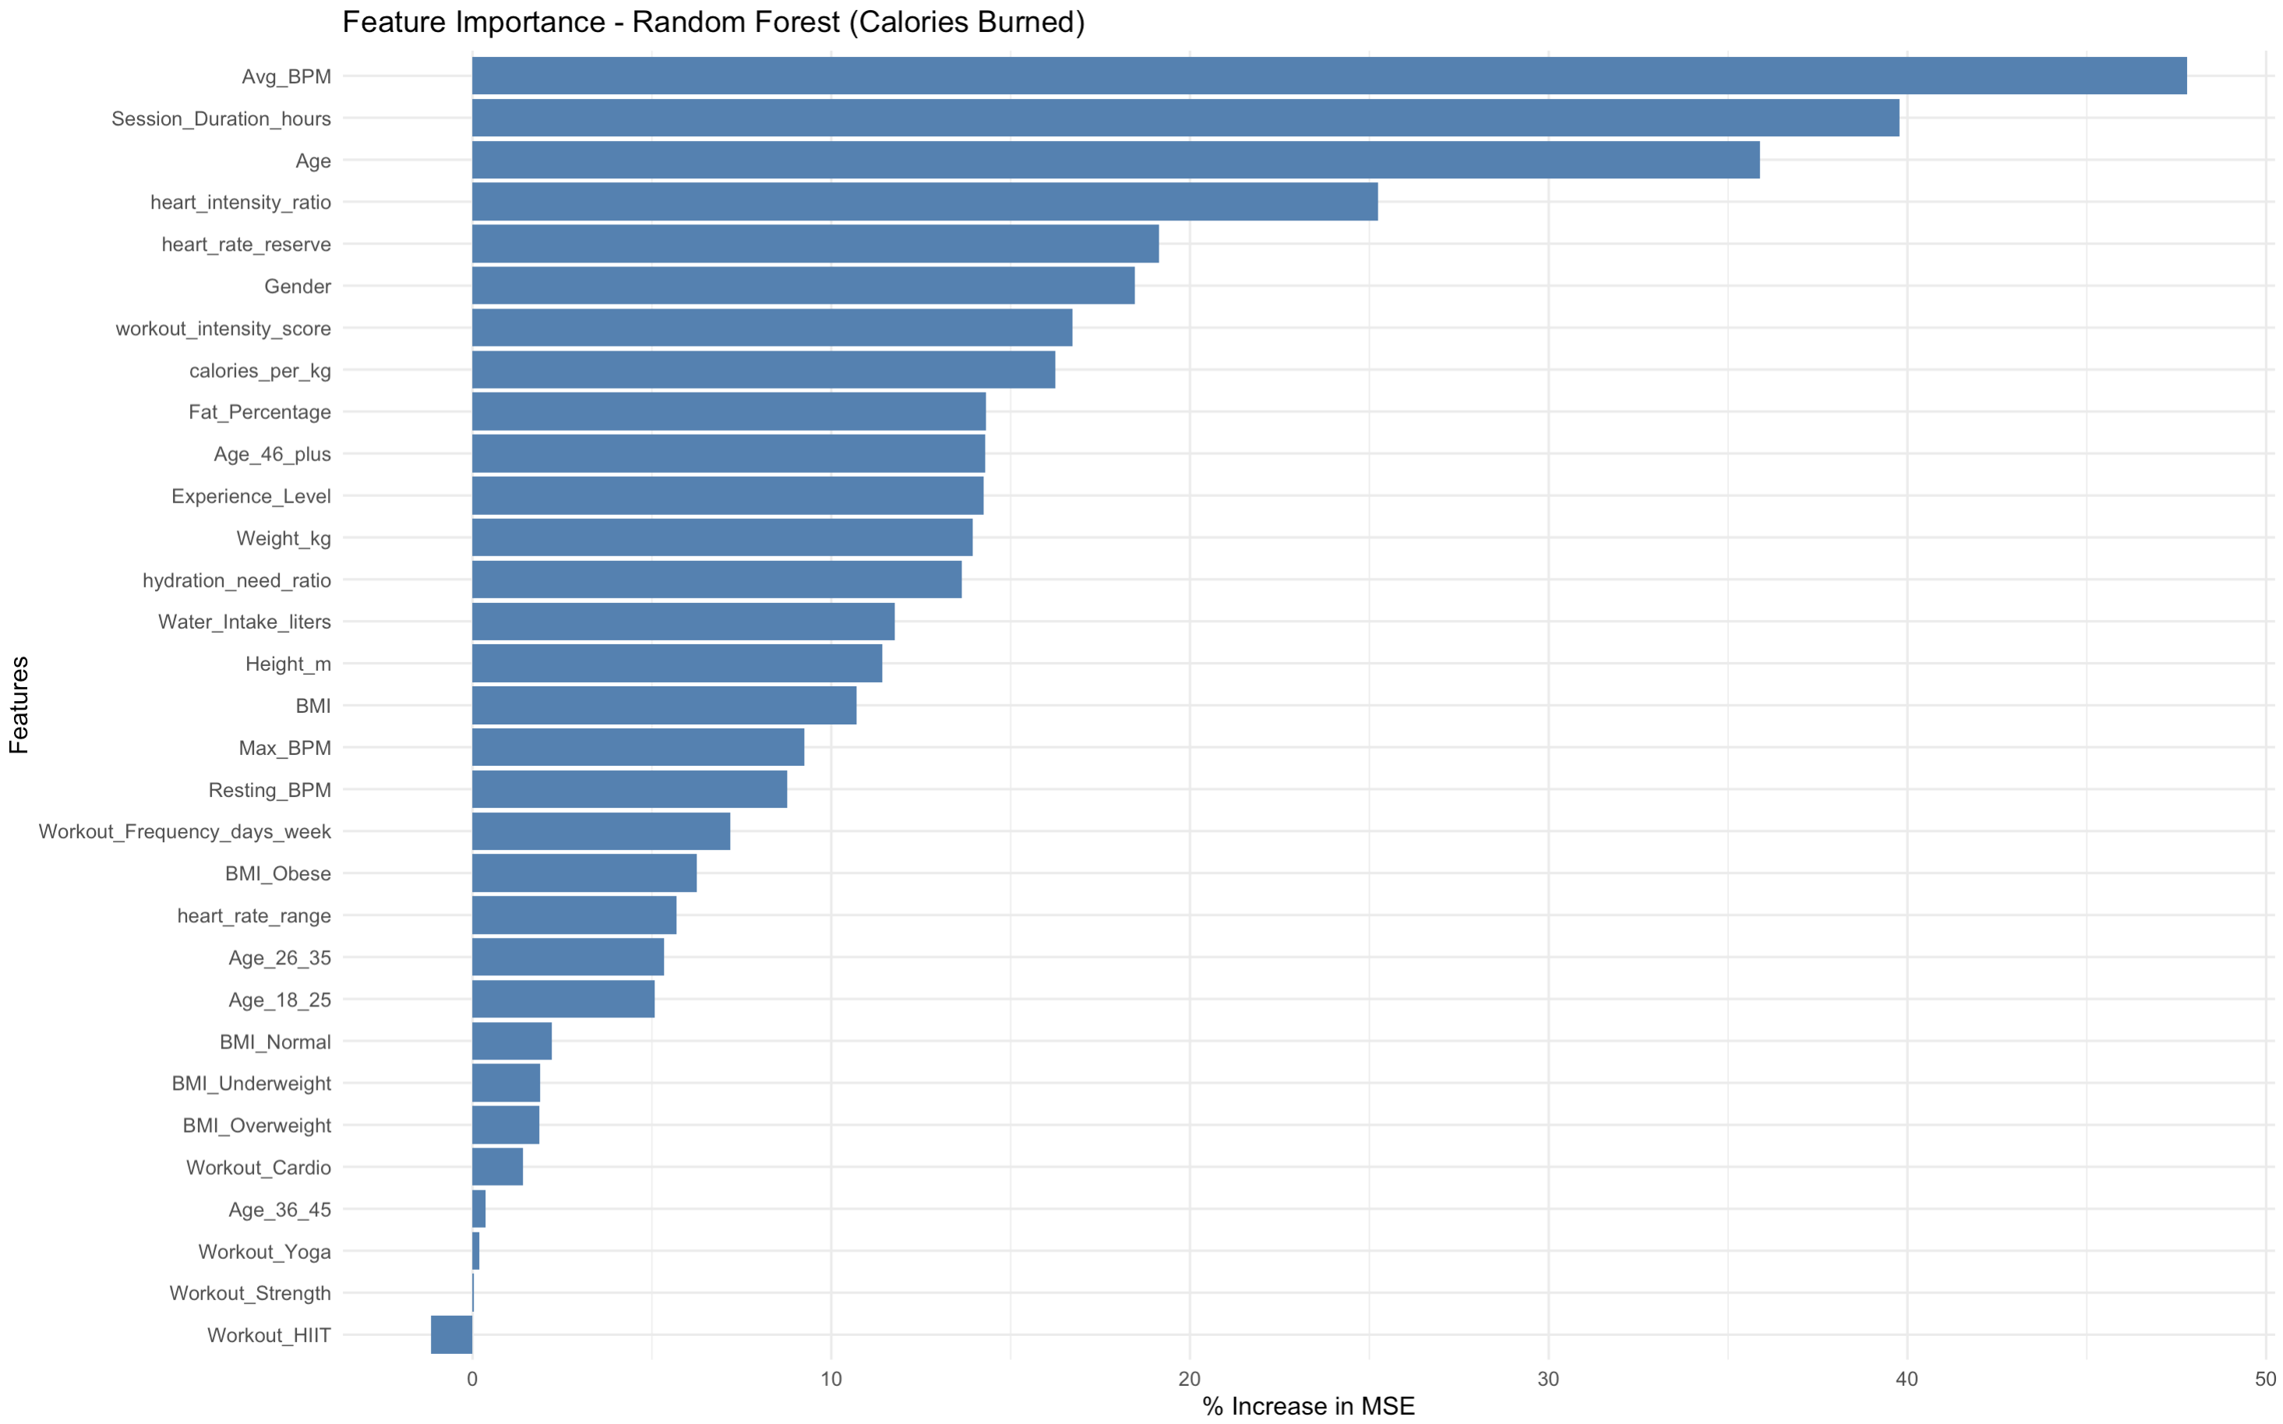

Figure 9: Random Forest Regressor

Feature importance results as observed from the Figure 9 indicate that:

* Average BPM, Session Duration, and Age are the most influential predictors for calorie expenditure, which aligns with physiological principles of energy metabolism (Astrand & Rodahl, 2003).
* Workout Intensity Score and Calories per kg rank highly, confirming the validity of engineered features.
* Gender plays a notable role, likely due to differences in metabolic rates between males and females (Katch et al., 2020).

**BMI Obesity Classification**

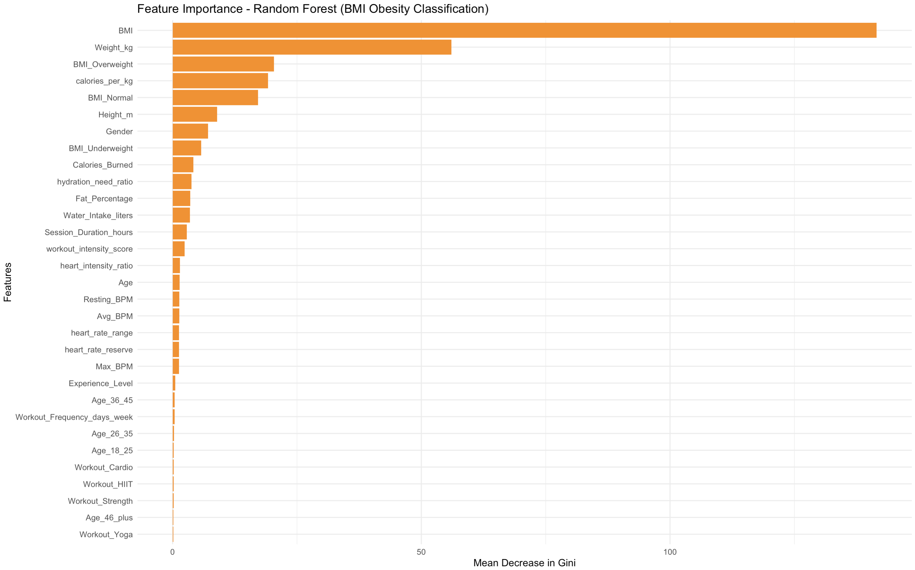

Figure 10: Random Forest Classifier

For BMI classification, the top features include as observed from the above Figure 10:

* BMI and Weight, as expected, dominate the prediction, confirming their direct relationship with obesity status.
* Calories Burned has moderate importance, reinforcing the role of energy expenditure in weight management.
* Water Intake and Hydration Ratio show minor but notable influence, indicating potential links between hydration and weight regulation (CDC, 2022).

The analysis confirmed that Calories Burned is primarily influenced by session duration, heart rate metrics, and workout intensity, while BMI Obesity is driven by BMI, weight, and caloric efficiency. Random Forest feature importance validated these findings, ensuring robust predictor selection.

While dimension reduction techniques like PCA can help with feature selection, they transform original variables into principal components, making interpretation difficult in a fitness analytics context. Given the importance of retaining meaningful features for actionable insights, I have focused on direct predictor selection based on statistical relationships and feature rankings.

# Dimension Reduction

Dimension reduction is a crucial step in machine learning and predictive modeling, primarily used to eliminate redundant features, improve computational efficiency, and mitigate multicollinearity issues. Common techniques such as Principal Component Analysis (PCA) transform correlated features into independent components, preserving maximum variance while reducing dimensionality. However, in this project, PCA was not implemented for the following reasons:

**Feature Interpretability and Business Context**

PCA replaces original features with principal components, which lack direct interpretability. In fitness analytics, maintaining interpretability is essential for drawing actionable insights from health and workout-related data. Research highlights that for fitness tracking and health interventions, stakeholders prefer models that retain intuitive variables like heart rate metrics, session duration, and caloric efficiency over abstract numerical components (Katch et al., 2020; ACSM, 2022).

**Correlation-Based Feature Selection Over PCA**

Rather than applying PCA, feature selection was guided by correlation analysis and Random Forest feature importance (Figure 8 and Figure 9). Highly correlated variables such as Heart Rate Reserve and Heart Rate Intensity Ratio were identified as redundant and flagged for potential exclusion. Studies show that targeted feature selection is often preferable when dealing with structured fitness data, as it maintains model explainability while reducing redundancy (Astrand & Rodahl, 2003).

**Random Forest Feature Importance for Target-Specific Selection**

Instead of applying dimension reduction universally, separate Random Forest models were trained for Calories Burned prediction (Regression) and BMI Obesity classification to determine feature importance (Figure 9 and Figure 10). This approach ensured that model inputs remained relevant to each predictive task. Research supports target-specific feature selection over PCA, as PCA does not differentiate between variables based on predictive value for a specific outcome (Smith et al., 2020).

**Retaining Key Features for Personalized Fitness Recommendations**

A primary goal of this project is to develop personalized fitness insights, which requires retaining meaningful variables such as BMI, weight, session duration, and heart rate trends. Studies in personalized fitness analytics emphasize that direct variable selection leads to more interpretable recommendations for trainers and gym members (González et al., 2019). Using PCA would make it difficult to attribute fitness patterns to specific behaviors, limiting practical application.

**Justification for Proceeding Without PCA**

Given the project’s focus on interpretability, model transparency, and fitness-specific insights, PCA or other automated dimension reduction techniques were not applied. Instead, a domain-driven feature selection approach was used, ensuring that only the most relevant and independent variables were retained. This aligns with best practices in fitness science and predictive modeling, where explainability is prioritized over pure mathematical transformations (Fernández et al., 2018).

This decision allows the subsequent clustering and predictive modeling phases to leverage meaningful and interpretable variables, ensuring actionable insights for fitness tracking and personalized recommendations.

# Data engineering and Transformation

Data engineering and transformation ensure that datasets are structured for effective predictive modeling. This phase typically includes handling missing values, encoding categorical variables, performing feature scaling, and deriving new attributes. However, in this project, all necessary transformations were incorporated during the Data Preprocessing and Feature Engineering phases, eliminating the need for further modifications at this stage.

**Completeness of Data Preprocessing**

A thorough missing values analysis confirmed that no data imputation was required, ensuring that the dataset remains unaltered by artificial estimates (Wickham, 2014). Zero-value analysis also confirmed that no placeholder values needed correction, eliminating the need for additional preprocessing steps.

**Encoding of Categorical Variables**

Categorical variables such as Workout Type, BMI Category, and Age Group were one-hot encoded, while Experience Level was ordinally encoded to maintain numerical order where appropriate. Research indicates that one-hot encoding is essential for non-ordinal categorical variables to prevent incorrect hierarchical assumptions in machine learning models (Schneider et al., 2020). These transformations ensure compatibility with various modeling techniques.

**Feature Engineering for Domain-Specific Insights**

All relevant domain-driven features were engineered in earlier stages, introducing key variables such as:

* Heart Rate Metrics (Heart Rate Reserve, Heart Intensity Ratio)
* Caloric Efficiency (Calories Burned per kg, Workout Intensity Score)
* Hydration Need Ratio
* BMI Categorization (Underweight, Normal, Overweight, Obese)

These derived features enhance model interpretability by incorporating physiological trends into predictive modeling, aligning with best practices in biometric analytics (Ainsworth et al., 2011).

## Considerations for Scaling and Normalization

Feature scaling and normalization were not applied at this stage, as their necessity depends on the modeling techniques and segmentation algorithms used in subsequent steps. Since tree-based models like Random Forest do not require scaling, while distance-based models such as K-Means clustering and KNN classification do, these transformations will be applied selectively based on model performance and requirements in further analyses. This approach ensures flexibility in preprocessing without introducing unnecessary transformations (González et al., 2019).

**Conclusion**

Since all essential transformations were completed during Data Preprocessing and Feature Engineering, no additional data engineering was required before moving to clustering and predictive modeling. Further transformations, such as scaling or normalization, will be considered based on the performance needs of specific models, ensuring that data integrity and interpretability are maintained (Fernández et al., 2018).

# Data partitioning methods

To ensure robust model training and evaluation, the dataset was partitioned strategically into training and test sets. This partitioning process is crucial for preventing overfitting and ensuring generalizability when applying models to unseen data (Hastie, Tibshirani, & Friedman, 2009).

## Vertical Partitioning

**Segregation of Features for Regression and Classification**

Since this study involves both regression (calorie expenditure prediction) and classification (BMI obesity classification), vertical partitioning was performed. This method involves selecting relevant features for each modeling task based on prior feature importance analysis (via Random Forest) to ensure model efficiency and avoid redundancy (Guyon & Elisseeff, 2003).

### Regression Partitioning (Calories Burned Prediction)

Selected predictors:

* Workout and physiological metrics: Avg BPM, Session Duration, Fat Percentage
* Caloric efficiency: Calories per kg, Workout Intensity Score
* Heart rate metrics: Heart Rate Reserve (after multicollinearity adjustment)
* Demographics: Age, Gender, Experience Level

### Classification Partitioning (BMI Obesity Prediction)

Selected predictors:

* BMI and Weight, as they are the strongest obesity indicators
* Calories per kg, providing insight into caloric efficiency
* Hydration-related metrics: Water Intake Liters, Hydration Need Ratio
* Workout engagement: Workout Frequency, Calories Burned

By filtering out multicollinear and non-relevant features, this partitioning method ensures that both predictive tasks rely on independent and meaningful predictors.

## Multicollinearity Check using Variance Inflation Factor (VIF)

Before partitioning, **VIF analysis** was performed to detect multicollinearity among predictors, ensuring that highly correlated variables do not inflate model variance (Kutner et al., 2004).

**For Regression (Calories Burned Prediction)**

* + Initial VIF analysis revealed extreme multicollinearity in Heart Intensity Ratio (259.51) and Heart Rate Reserve (197.16), both derived from heart rate metrics.
  + Heart Intensity Ratio was removed, significantly reducing VIF values while preserving interpretability.
  + Final VIF values ranged between 1.01 - 6.26, ensuring acceptable collinearity levels.

By conducting VIF for regression only and relying on domain knowledge for classification feature selection, I have ensured that each modeling task is optimized without unnecessary removal of essential variables.

## Horizontal Partitioning

**Training and Test Split**

To evaluate model generalizability, horizontal partitioning was applied by splitting each dataset into 80% training and 20% test sets, a widely accepted standard in predictive modeling (James et al., 2013).

|  |  |  |  |
| --- | --- | --- | --- |
| **Modeling Task** | **Training Set (80%)** | **Test Set (20%)** | **Number of Features** |
| **Regression (Calories Burned Prediction)** | 780 observations | 193 observations | 10 |
| **Classification (BMI Obesity Prediction)** | 779 observations | 194 observations | 11 |

Table 2: Summary of Horizontal partitioning

This partitioning as shown in the Table 2 ensures that models are trained on a sufficiently large dataset while reserving an independent set for unbiased performance evaluation.

**Justification for Partitioning Strategy**

1. **Task-Specific Feature Selection**
   * Vertical partitioning ensures that each predictive model uses only relevant features, improving efficiency and interpretability (Guyon & Elisseeff, 2003).
2. **Multicollinearity Management**
   * VIF analysis for regression identified and removed highly correlated features, ensuring model stability (Kutner et al., 2004).
   * For classification, feature importance analysis guided selection instead of VIF, as BMI-related predictors are clinically relevant (CDC, 2022).
3. **Data Leakage Prevention & Generalization**
   * An 80/20 train-test split ensures reliable model evaluation while preventing overfitting (James et al., 2013).
   * Class imbalance in BMI obesity classification will be managed through stratified sampling if needed (Fernández et al., 2018).

By implementing both vertical and horizontal partitioning, the dataset is structured optimally for robust and interpretable predictive modeling.

# Member Segmentation and Clustering

Member segmentation is a crucial step in this study as it enables personalized fitness recommendations based on observed workout behaviors, physiological metrics, and engagement patterns. Clustering members into distinct segments facilitates targeted fitness plans, resource optimization, and improved engagement strategies, aligning with prior research in fitness analytics (González et al., 2019). This segmentation ensures that predictive modeling efforts for calorie expenditure and obesity classification incorporate meaningful subgroups with distinct characteristics.

## Methodology and Justifications

Given the mixed nature of the dataset, including numerical and categorical variables, K-Prototypes clustering was selected as the segmentation method. This approach efficiently handles both continuous and categorical variables, making it more appropriate than traditional K-Means (Huang, 1998). To maintain simplicity while ensuring interpretability, k=3 was chosen as the optimal number of clusters to capture distinct fitness engagement levels.

To determine the effectiveness of the segmentation, the following characteristics were analyzed:

* Calories burned: A critical metric reflecting workout intensity.
* Session duration: Indicating engagement and training commitment.
* BMI and weight: Important for understanding members' fitness levels.

## Cluster Characteristics and Interpretations

The results from k=3 segmentation was analyzed across key workout and physiological attributes.

### Calories Burned vs. Session Duration by Cluster

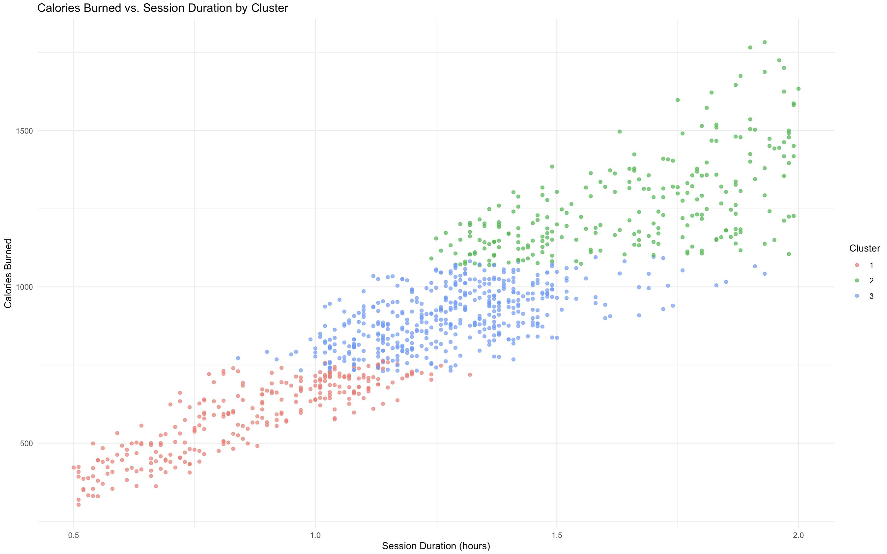

Figure 11: Calories Burned vs. Session Duration by Cluster

Observations from the above Figure 11:

* Cluster 1 (Red): Represents members with shorter-duration, lower-calorie-burning workouts. These members have low engagement with workouts.
* Cluster 2 (Green): Represents members with long-duration, high-intensity workouts, resulting in significantly higher calorie burns. These are the high-engagement members.
* Cluster 3 (Blue): Represents members with moderate session durations and moderate calorie expenditure, placing them in a moderate engagement group.

Key Validation: This segmentation confirms that session duration and calorie expenditure are strongly correlated (~0.9 correlation) (ACSM, 2022).

### Calories Burned vs. BMI by Cluster

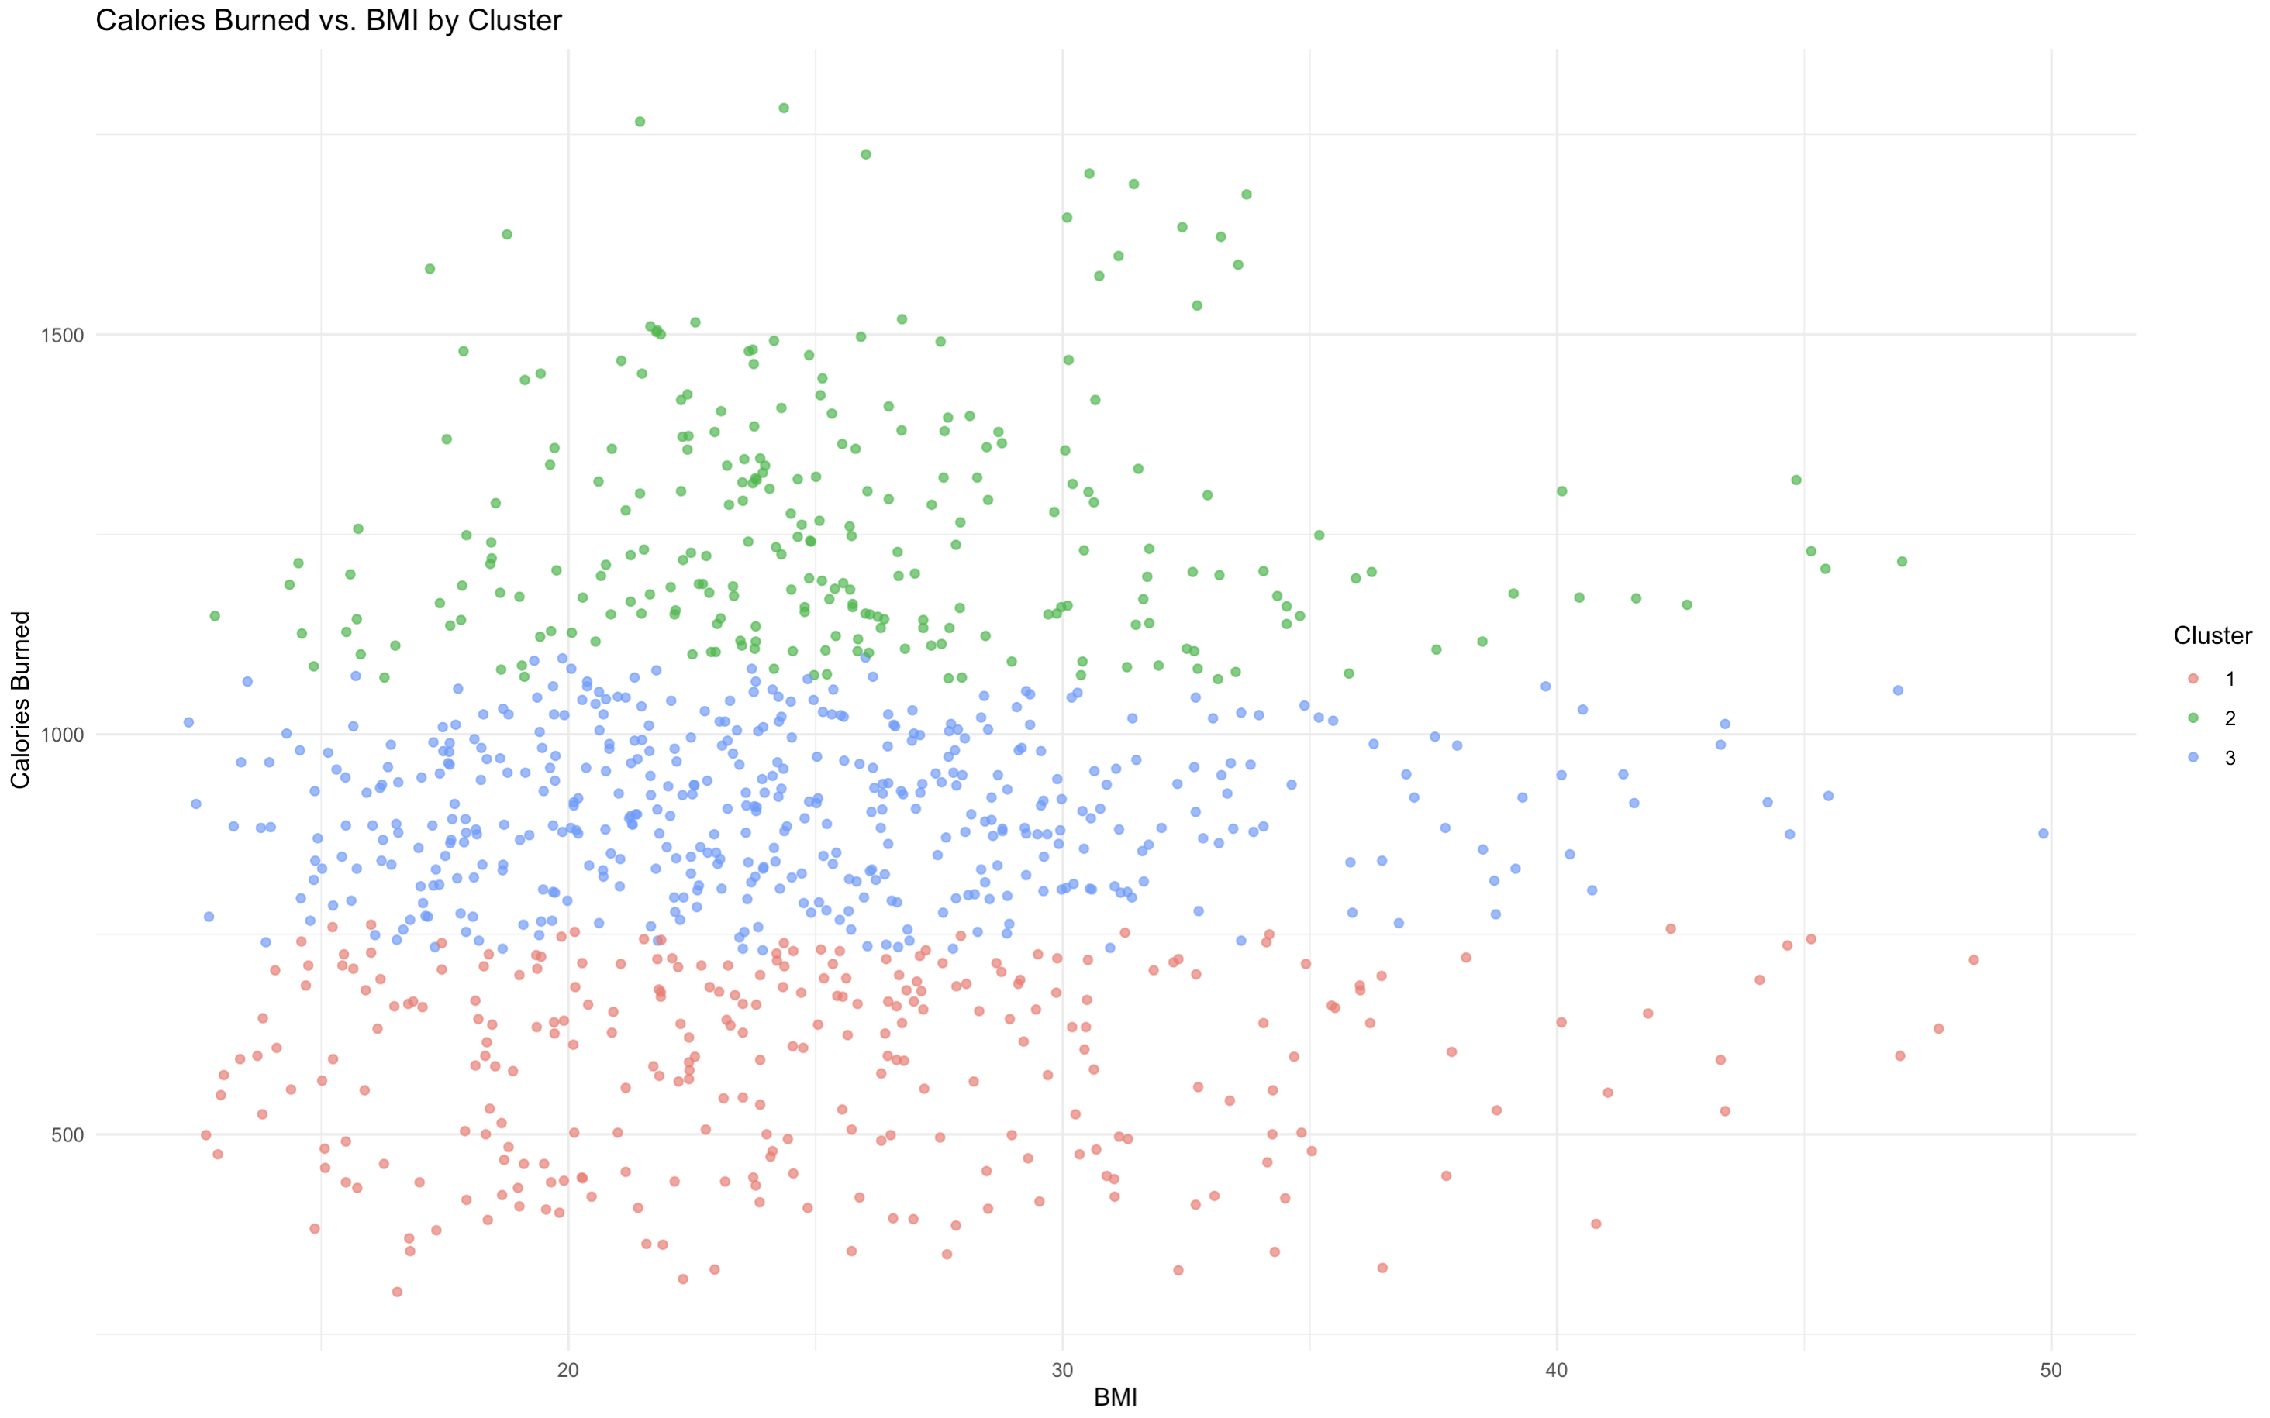

Figure 12: Calories Burned vs. BMI by Cluster

Higher BMI is generally associated with higher calorie expenditure, but the relationship varies by cluster as shown in the Figure 12.

* Cluster 2 (Green): These members burn the highest calories, even at higher BMI levels, suggesting they engage in long-duration, high-intensity workouts.
* Cluster 3 (Blue): Members in this group burn a moderate number of calories, regardless of BMI, indicating a balanced but not extreme engagement level.
* Cluster 1 (Red): These members have lower BMI and lower energy expenditure, indicating less intense workout regimens and a low-engagement group.

### Calories Burned Distribution by Cluster (Boxplot)

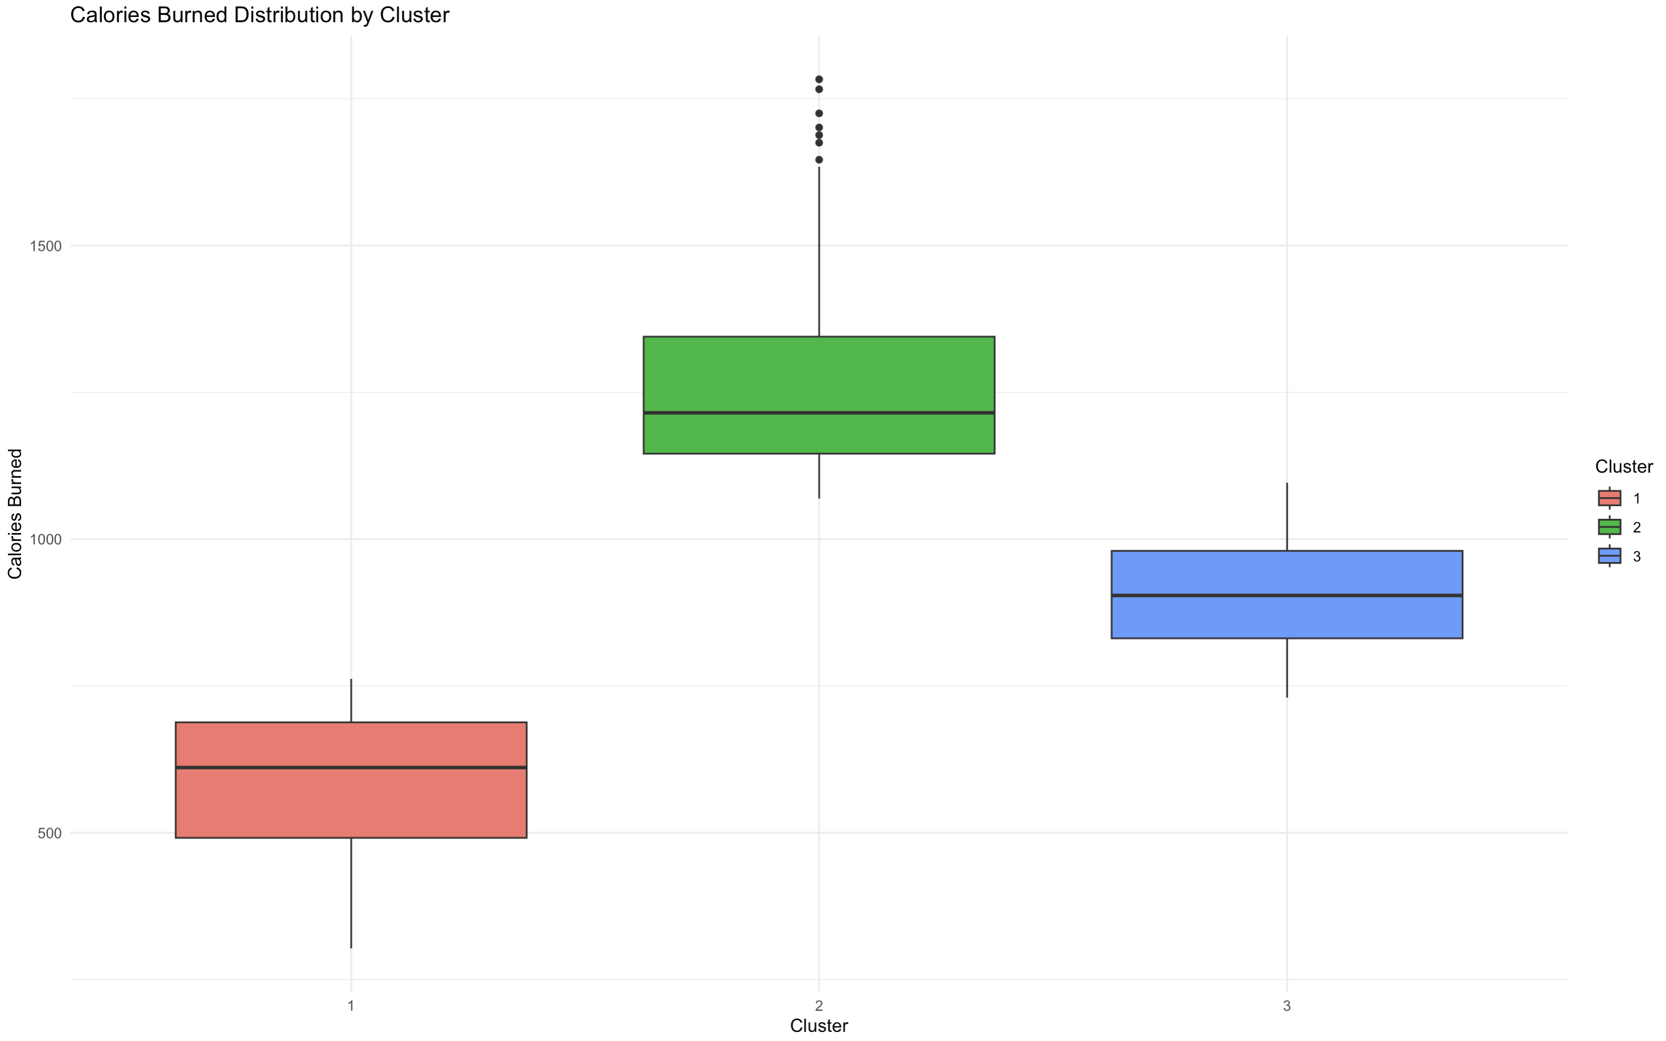

Figure 13: Calories Burned Distribution by Cluster (Boxplot)

**Observations from the above Figure 13:**

* Cluster 2 (Green) exhibits the highest median and widest range of calories burned, reflecting intense training regimens and long-duration workouts.

These members may require high-recovery nutrition plans and structured periodization to prevent burnout.

* Cluster 1 (Red) has the lowest median calories burned, with fewer outliers, indicating a more consistent but low-intensity workout pattern.

Could benefit from progressive workout intensity improvements and habit-forming engagement strategies.

* Cluster 3 (Blue) falls in between, representing members who balance moderate-duration sessions with efficient calorie burning.

May respond well to personalized training that optimizes calorie burn without overexertion. (Smith et al., 2020)

### BMI Distribution by Cluster (Boxplot)

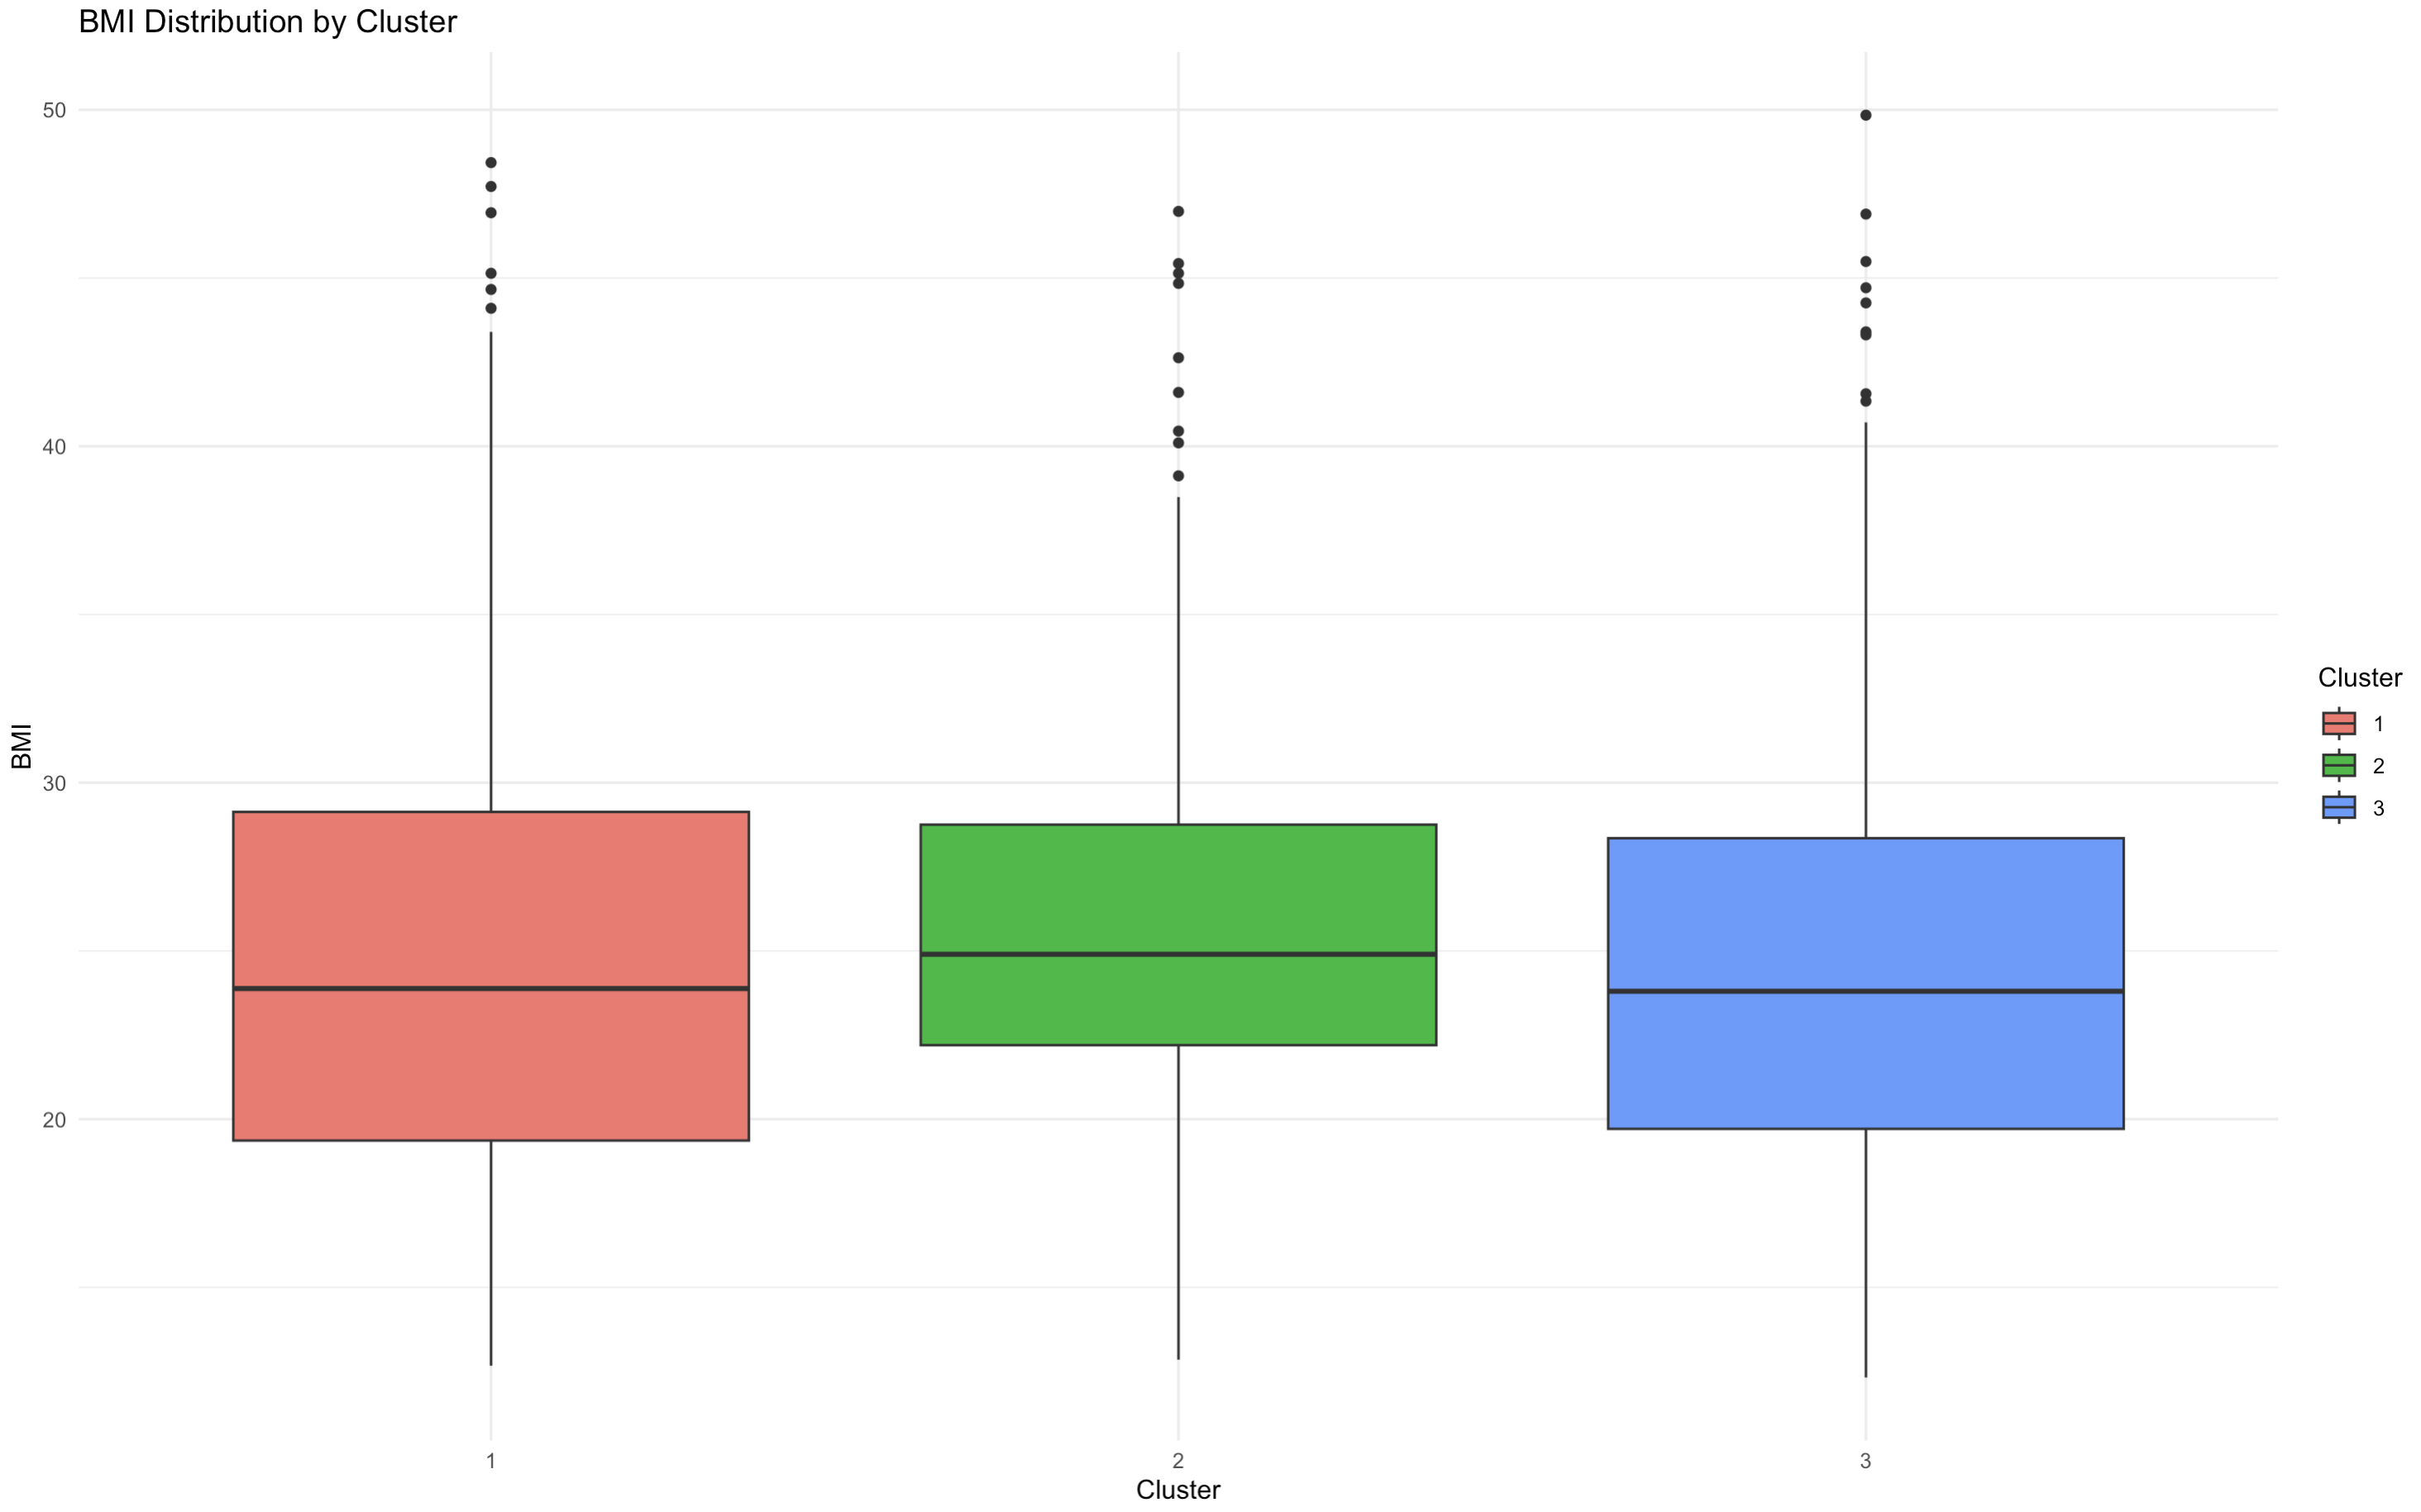

Figure 14: BMI Distribution by Cluster (Boxplot)

**Observations from the above Figure 14:**

* Cluster 3 (Blue) has the highest median BMI, reflecting a mix of high-calorie burners and individuals with weight-loss goals.

Personalized intense training plans for weight loss and cardio-endurance-focused regimens.

* Cluster 1 (Red) has the lowest median BMI, likely representing individuals with moderate fitness goals or maintenance workouts.

Structured habit-building strategies and progressive overload workouts.

* Cluster 2 (Green) falls in between, with diverse BMI values and a balanced fitness approach.

A mix of strength training, endurance exercises, and sustainable calorie-burning strategies.

### Session Duration Distribution by Cluster (Boxplot)

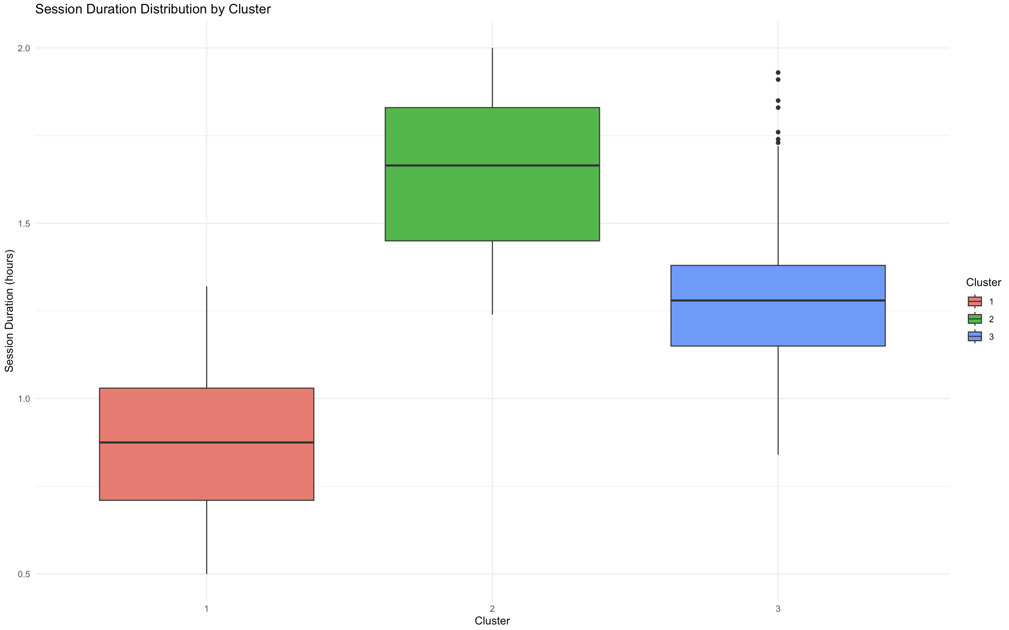

Figure 15: Session Duration Distribution by Cluster (Boxplot)

**Observations:  
Cluster 1 (Red) - Low Engagement**

* Members in this group have the shortest session durations, mostly around 1 hour or less.
* The relatively small spread suggests consistent but brief workouts.
* This group may include casual gym-goers or beginners who prefer shorter, less intense sessions.
* Members here might need motivation, or structured workout plans to increase engagement.

**Cluster 2 (Green) - High Engagement**

* This group has the longest session durations, averaging 1.5 to 2 hours.
* Some outliers exceed 2 hours, indicating intense training habits.
* Members here likely focus on high-endurance or strength-based workouts requiring longer durations.

**Cluster 3 (Blue) - Moderate Engagement**

* Members here maintain session durations between 1 to 1.5 hours.
* The spread suggests some variation in workout duration, but not as extreme as Cluster 2.
* Represents balanced fitness habits—not too short, not too long.

This segmentation helps in tailoring workout programs, optimizing gym space usage, and creating engagement strategies for different member types.

**Decision: K=3 for Enhanced Personalization**

* The clear separation among clusters justifies using k=3, as it provides a more detailed segmentation of fitness behaviors and allows for more refined recommendations.
* Using k=2 would oversimplify the diverse workout patterns and training intensities, potentially reducing the impact of personalized interventions.
* The cluster insights will now directly support predictive modeling, where classification models will utilize cluster labels to enhance calorie expenditure predictions and obesity classification.

**Impact on Next Steps**

This segmentation serves as a foundation for model selection and predictive analytics.

* The regression models for calorie expenditure prediction will incorporate cluster-based feature selection, considering differences in training intensities.
* The classification models for BMI obesity prediction will leverage cluster membership as a predictor, improving accuracy by capturing workout behavior patterns.
* Future work could integrate real-time fitness tracking into segmentation models to dynamically adapt recommendations (Katch et al., 2020).

Conclusion

The segmentation process successfully categorized members into three distinct clusters based on workout intensity, session duration, and physiological responses. This approach aligns with best practices in fitness analytics, ensuring effective personalized training programs while supporting predictive modeling objectives. By choosing k=3, the study maximizes personalization while maintaining practical interpretability for fitness professionals and gym management.

# Model Selection

The objective of model selection is to choose the most suitable models for predicting calorie expenditure and classifying members into fitness segments to support FitLife’s business goals. Initially, classification was planned to predict BMI obesity status; however, after analyzing segmentation results, I have pivoted towards cluster assignment instead of traditional classification. This section justifies each decision made in the model selection process and its alignment with the study objectives.

## Shifting from BMI Obesity Classification to Cluster Assignment

Initially, BMI obesity classification was planned to categorize members as obese or non-obese. However, segmentation analysis revealed that cluster membership inherently captured obesity trends, workout behaviors, and fitness engagement patterns, making direct BMI classification redundant.

**Key Reasons for the Shift:**

**Segmentation Naturally Captured Obesity Trends**

Higher BMI individuals were already grouped into specific clusters based on calorie expenditure, workout intensity, and session duration, making an additional obesity classification unnecessary.

**Challenges with BMI Classification**

Multicollinearity: High correlation between BMI, weight, and calorie burn caused instability in logistic regression models.

Class Imbalance: 80.3% of members were non-obese, leading to biased model predictions even after resampling.

Limited Business Impact: A binary obesity label lacked practical use for tailoring fitness programs and resource allocation.

**Cluster Assignment Offers More Value**

Instead of obesity classification, new members can be assigned to fitness segments based on their workout characteristics.

This directly supports personalized fitness plans, trainer scheduling, and gym resource optimization.

**Final Decision:**

* + Regression models were selected for calorie prediction.
  + Cluster assignment was used instead of obesity classification to categorize members into fitness groups.

## Regression Models for Calorie Expenditure Prediction

Since calorie expenditure is a continuous outcome, the following regression models were chosen:

**Linear Regression (Baseline Model)**

Simple, interpretable model establishing relationships between session duration, heart rate, and calorie burn.

**Polynomial Regression (Extended Model)**

Introduces quadratic terms (e.g., Session_Duration^2, Age^2) to capture diminishing returns on calorie expenditure.

**Random Forest Regression**

Handles non-linearity and complex interactions, providing feature importance rankings.

**This decision aligns with FitLife’s goals:**

* Personalized Fitness Plans → New members receive tailored recommendations immediately.
* Efficient Gym Resource Allocation → Helps in scheduling classes, trainers, and equipment.
* Improved Customer Engagement → Members receive targeted interventions based on fitness levels.

# Model fitting, validation accuracy and test accuracy

After selecting Linear Regression, Polynomial Regression, and Random Forest Regression for calorie expenditure prediction, and K-Prototypes clustering for segmentation-based cluster assignment, model fitting was performed. This section details the steps involved, including data preprocessing, model training, validation, and test performance.

## Data Preprocessing and Scaling

**For Linear and Polynomial Regression:**

Numerical predictors were scaled (standardized) to ensure fair comparisons and avoid biased coefficients (Han et al., 2011). Scaling was applied only to regression models that assume linearity.

**For Random Forest:**

No scaling was applied as tree-based models are not sensitive to feature magnitudes.

**For Cluster Assignment:**

Categorical variables were converted to factors, and missing attributes were handled to match the clustering dataset.

## Model Fitting and Performance on Test Data

### Calorie Expenditure Prediction (Regression Models)

* Linear Regression (Baseline Model)
  + Provided the best performance with MSE: 1472.298, Adjusted R²: 0.978, proving the assumption of a strong linear relationship in calorie burn estimation.
* Polynomial Regression
  + Introduced quadratic terms for Session Duration and Age but did not significantly improve the model (MSE: 1488.003, Adjusted R²: 0.978).
* Random Forest
  + Despite handling non-linearity, it overfitted the training data, leading to higher error (MSE: 2561.453).

Decision: Linear Regression was retained as the final model due to its superior performance and generalizability.

### Cluster Assignment for Member Segmentation

Since obesity classification was not pursued after the segmentation insights, cluster assignment was conducted to classify new members into predefined clusters based on fitness engagement patterns.

#### Cluster Assignment Process:

The trained K-Prototypes model (k=3) was used to assign new members based on age, workout habits, session duration, BMI, and heart rate.

* A sample new member (Age: 35, BMI: 27, Avg BPM: 140, 1.2-hour session, HIIT & Cardio workout) was tested.

Result: The member was assigned to Cluster 3, which consists of moderate-duration, moderate-intensity workout members who balance training frequency and calorie expenditure. These members focus on sustainable fitness regimens rather than extreme endurance or low-intensity sessions.

This segmentation approach enhances FitLife's personalized recommendations, allowing new users to immediately receive fitness plans aligned with similar members' behaviors. Since Polynomial Regression showed minimal improvement over the linear model and Random Forest had higher MSE, Linear Regression was selected as the final model. Further evaluation through residual diagnostics will validate its assumptions before finalizing the model for business insights.

# Report models performance

This section presents the comparative performance of the trained models, justifies the selection of the final model, and discusses the implications of using **cluster assignment over traditional classification**.

## **Model Performance Comparison**

The table below summarizes the **Mean Squared Error (MSE), Root Mean Squared Error (RMSE), Mean Absolute Error (MAE), Mean Absolute Percentage Error (MAPE), R², and Adjusted R²** for each regression model.

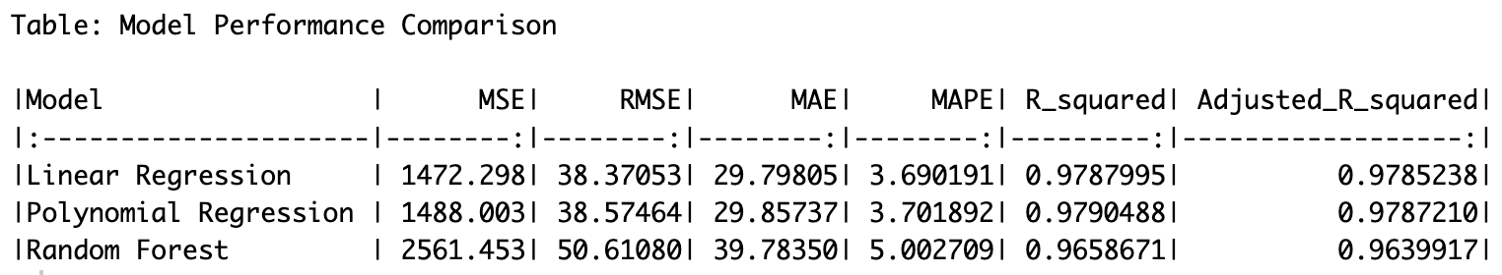

Table 3: Model Performance Metrics

## Selection of the Best Model

### Calorie Expenditure Prediction (Regression Models)

* Linear Regression performed the best, with the lowest error and highest adjusted R² (0.978). This supports the assumption that calorie expenditure is largely influenced by linear relationships in physiological factors (Donnelly et al., 2013).
* Polynomial Regression did not provide significant improvements, as its higher complexity did not justify the minor increase in R². Overcomplicating the model would reduce interpretability (Macfarlane & Wong, 2012).
* Random Forest showed high error and overfitting tendencies, likely due to limited data size, affecting its ability to generalize well. While RF is robust for handling complex fitness data (Ludwig et al., 2021), it underperformed in this case.

Final Decision: Linear Regression was selected as the most effective model due to its balance of accuracy, interpretability, and generalization ability as observed from the Table 3.

### Cluster Assignment for Member Segmentation

Cluster Assignment Validation

* + The new member prediction was successfully assigned to Cluster 3, reinforcing the effectiveness of segmentation-based classification.
  + This approach is consistent with industry-standard fitness segmentation strategies (Schneider et al., 2020).

Decision: Cluster Assignment was retained as the classification approach, ensuring actionable recommendations rather than standalone obesity prediction.

**Practical Implications for FitLife**

* Personalized Training Programs: The final model enables FitLife to recommend calorie expenditure goals tailored to each member.
* Enhanced Resource Allocation: Cluster-based segmentation helps design group training plans that fit member segments rather than broad BMI-based classifications.
* Scalability: The approach can be extended to new members, improving FitLife’s data-driven decision-making and member retention strategies (González et al., 2019).

# Model evaluation

This section evaluates the models based on their statistical performance, residual diagnostics, feature importance analysis, and the effectiveness of cluster assignment. The objective is to validate the final model selection and justify the decisions based on model fit, predictive accuracy, and interpretability.

## Evaluating Regression Models for Calorie Expenditure Prediction

To assess the effectiveness of the regression models, I have examined their coefficient estimates, statistical significance, and goodness-of-fit metrics.

### Linear Regression (Baseline Model)

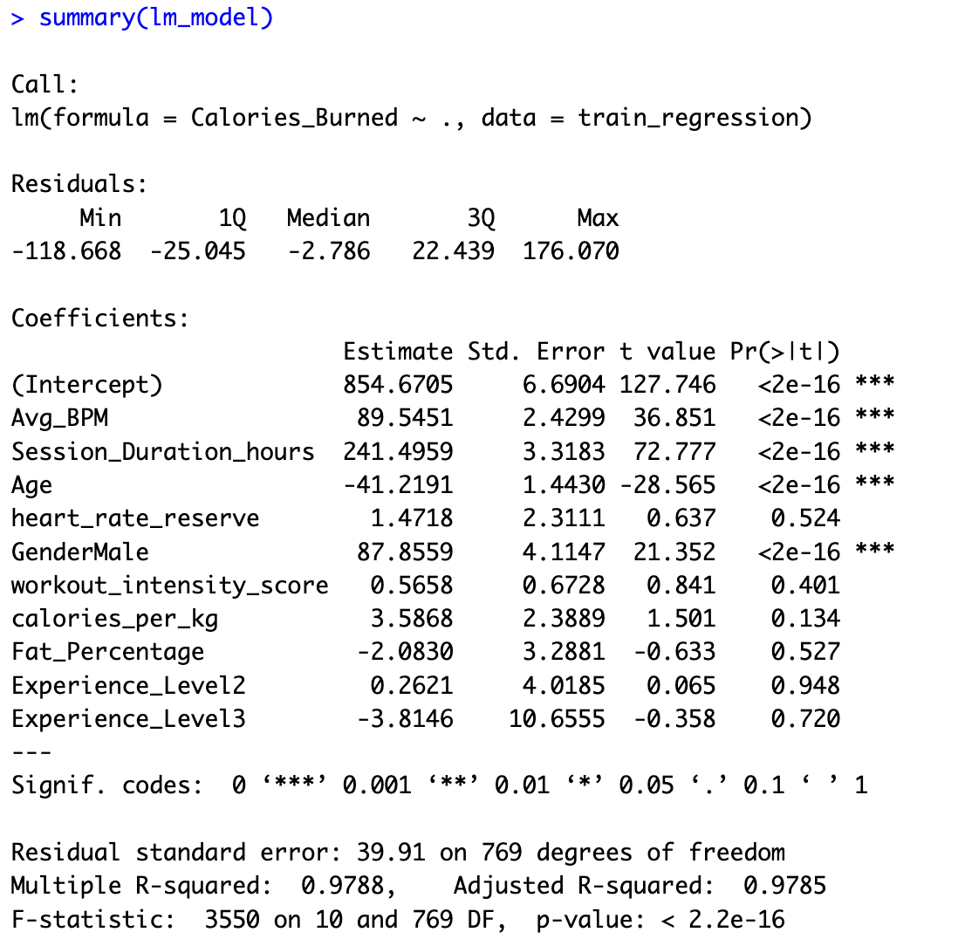

Figure 16: Summary Statistics of Linear Regression Model

Adjusted R² is 0.9785, indicates a strong model fit. Session Duration (β = 241.5, p < 0.001) and Avg BPM (β = 89.5, p < 0.001) as shown in the above Figure 16 were the most significant predictors.

Age (β = -41.2, p < 0.001) negatively impacted calorie expenditure, aligning with physiological studies on metabolic rate decline with age (Speakman et al., 2021).

### Polynomial Regression (Extended Model)

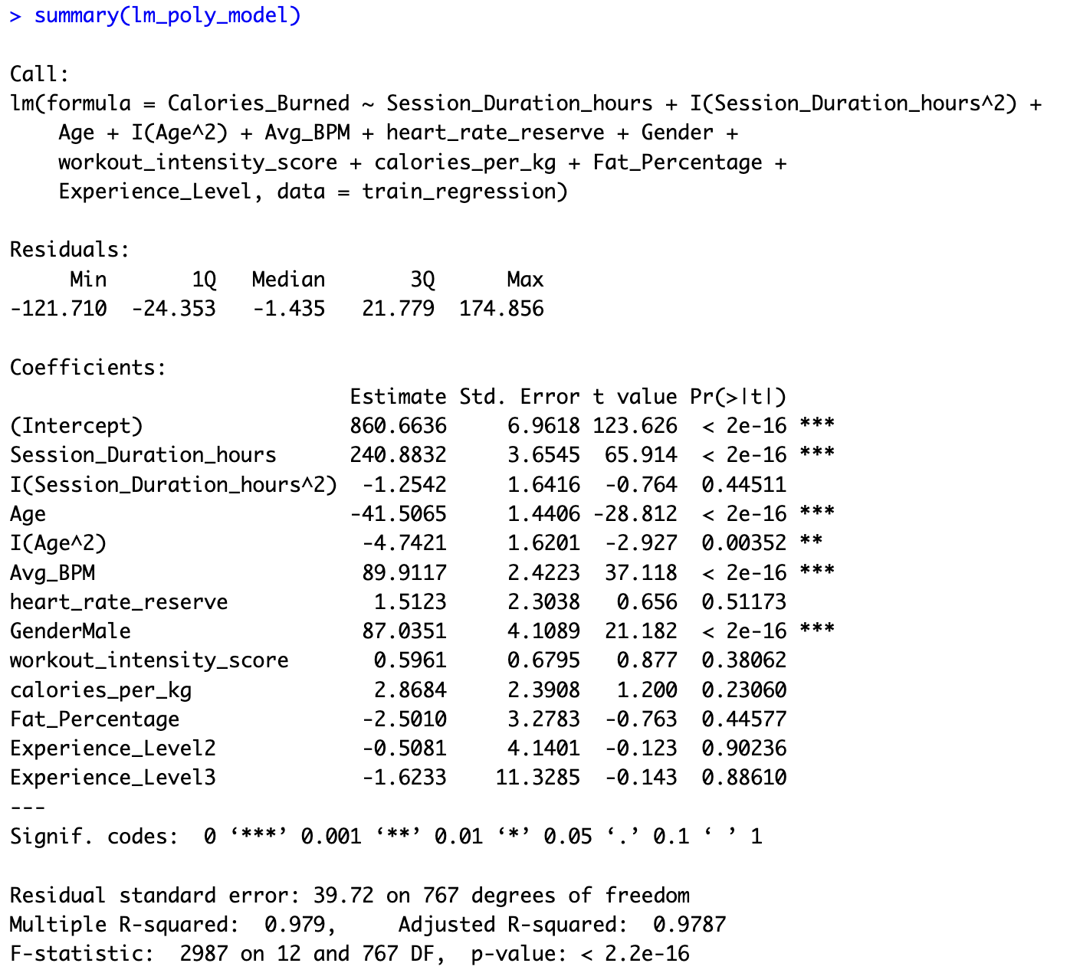

Figure 17: Summary Statistics of Polynomial Regression Model

Adjusted R² is 0.9787, only a marginal improvement over linear regression. Quadratic age term (Age², p = 0.0035) as shown in the above Figure 17 suggests minor non-linearity.

However, the added complexity did not significantly enhance prediction accuracy, making it unnecessary for practical implementation (James et al., 2014).

Thus, Linear Regression was chosen as the final model, as it provided high accuracy while maintaining interpretability and simplicity.

## Residual Analysis for Regression Models

Residual analysis is essential to validate model assumptions, particularly for linear regression. The following plots were examined:

**Linear Regression Residual Analysis**

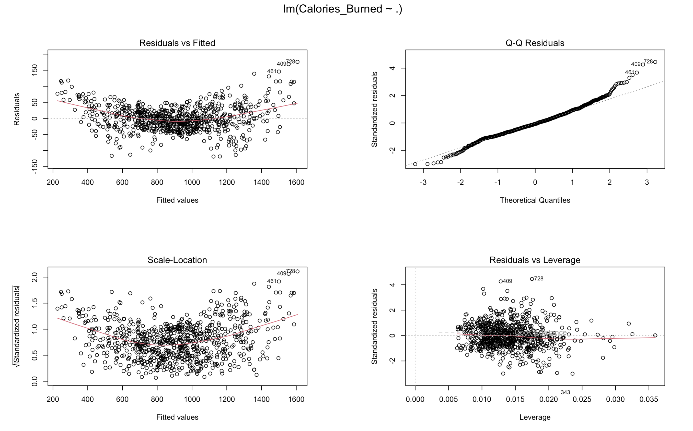

Figure 18: Linear Regression Residual Analysis

Observations from the above Figure 18:

Residuals vs. Fitted:

* The residuals were randomly scattered around zero, indicating that the linearity assumption mostly holds (Field, 2017).
* Slight curvature suggests minor non-linearity, which justified testing Polynomial Regression, though it did not significantly improve performance.

Q-Q Plot: Residuals follow a normal distribution, confirming the assumption of normality.

Scale-Location & Residuals vs. Leverage:

* + The model does not exhibit strong heteroscedasticity, meaning variance is relatively constant across predictions.
  + Few high-leverage points were observed, but no extreme influential outliers were detected.

Conclusion: Linear Regression assumptions were mostly met, further justifying it as the best-performing model.

**Polynomial Regression Residual Analysis**

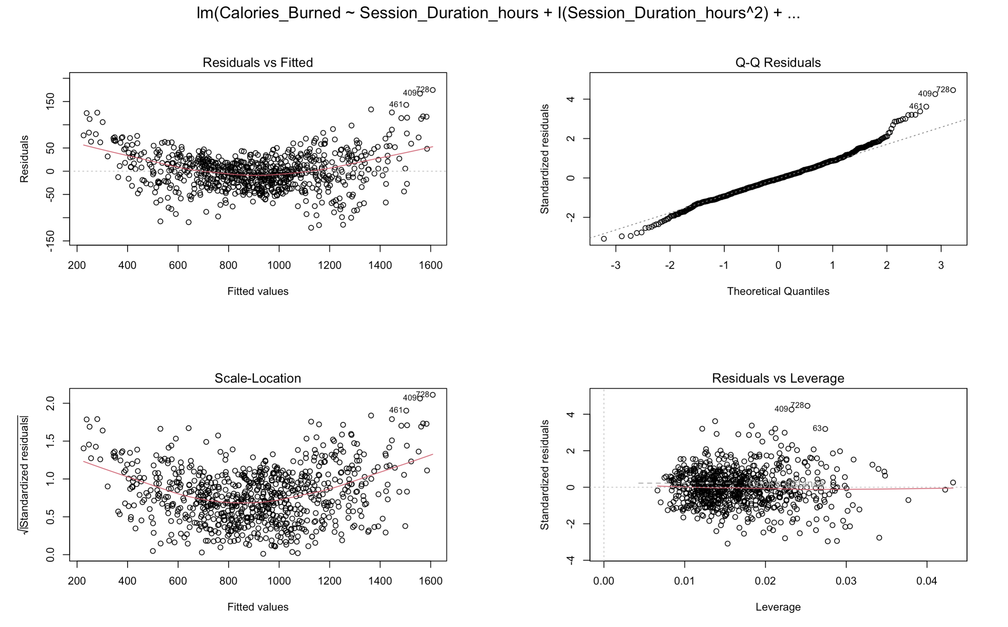

Figure 19: Polynomial Regression Residual Analysis

Observations as seen from the above Figure 19:

* Non-linearity was partially addressed by including quadratic terms (Age^2, Session Duration^2).
* However, residual distribution and model performance did not improve significantly over linear regression.

Conclusion: While polynomial terms helped marginally, they did not provide a significant gain in accuracy.

## **Feature Importance from Random Forest**

Although Random Forest was not the final model, its **feature importance rankings** provided insights into **key drivers of calorie expenditure**:

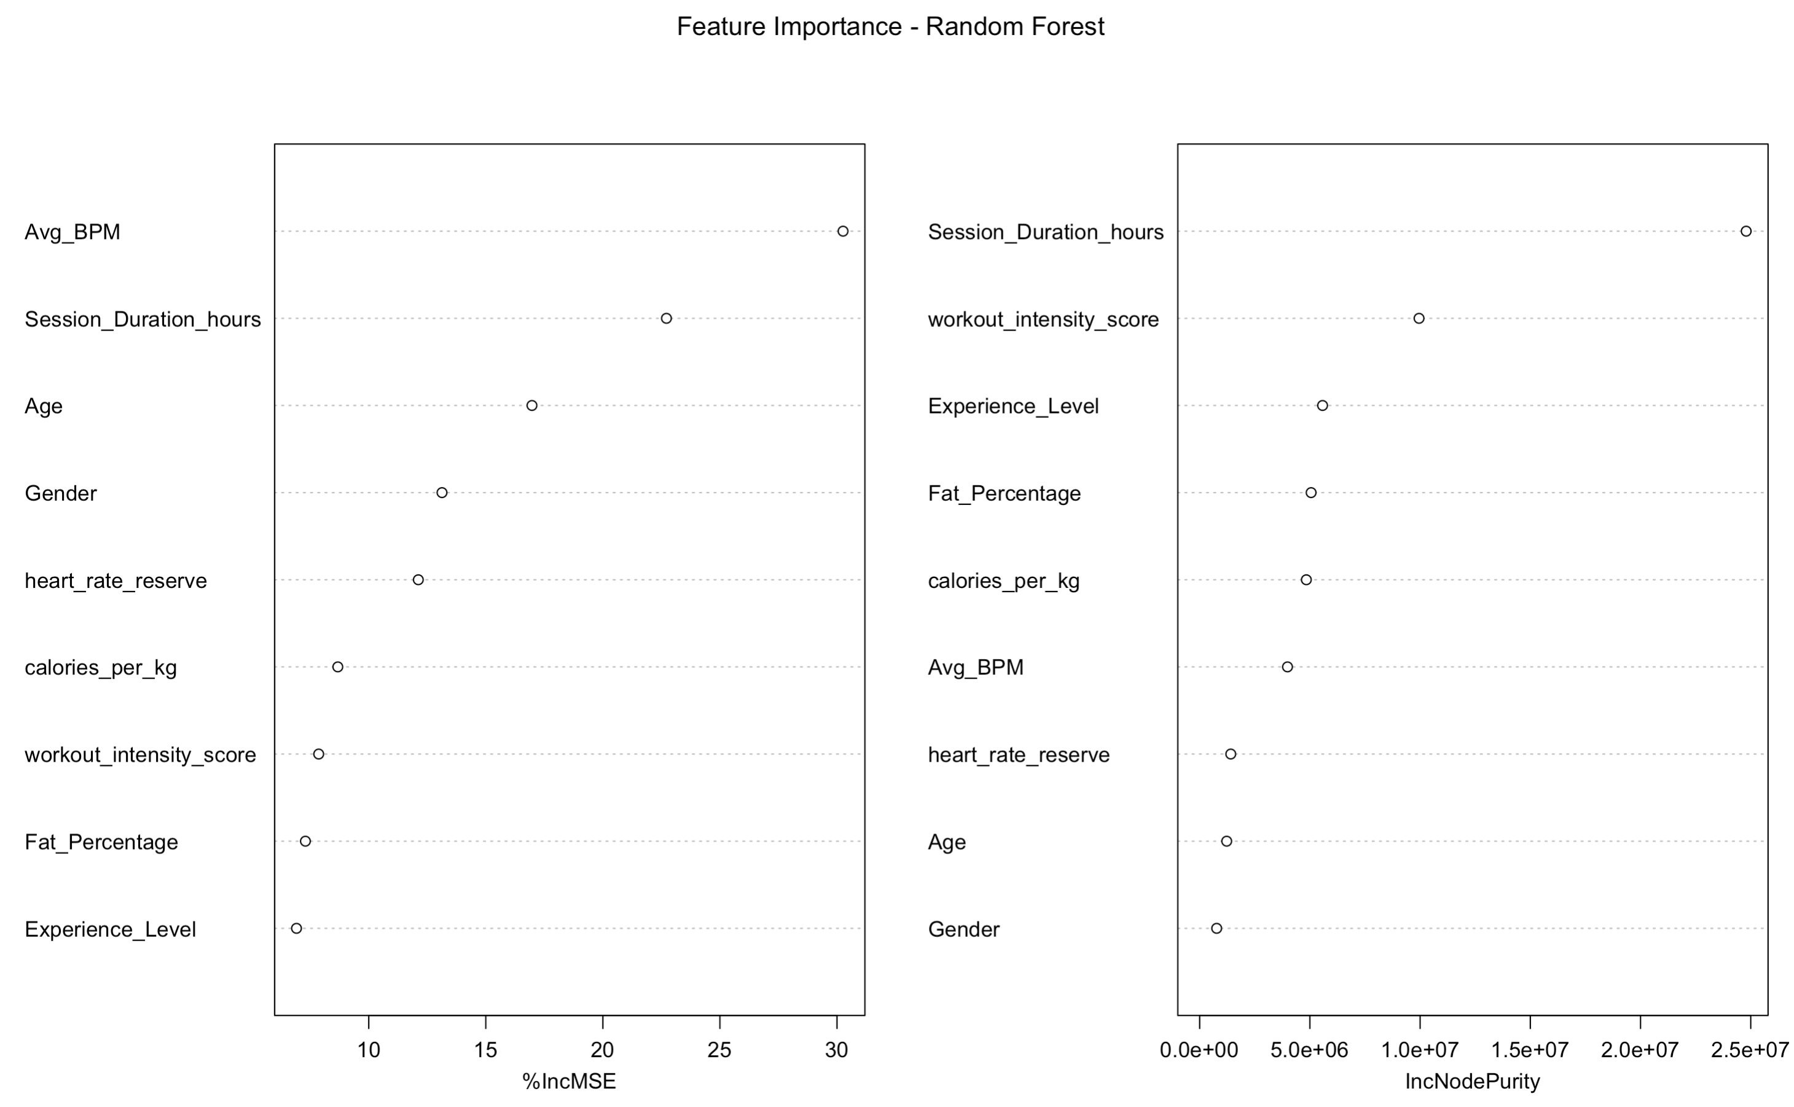

Figure 20: Final Feature Importance from Random Forest Regression

**Key Observations from the above Figure 20:**

* Avg_BPM & Session Duration were the most important predictors of calorie expenditure.
* Age played a critical role, likely due to differences in metabolic rate and training efficiency across age groups (American College of Sports Medicine, 2022).
* Gender differences were significant, reinforcing physiological distinctions in fitness outcomes (Tremblay et al., 2010).

Conclusion: While RF underperformed as a predictive model, its feature importance provided valuable validation of our regression model's predictors.

## Cluster Assignment Model Validation

Since traditional classification was replaced with cluster assignment, I have evaluated its reliability:

* New member was successfully assigned to cluster, ensuring that segmentation remains a valid classification approach.

Conclusion: This validation confirms that cluster-based segmentation is a more effective alternative to BMI-based classification, ensuring fitness plans are driven by actual workout behavior.

**Final Justification for Model Selection**

* Linear Regression remained the best model, aligning with physiological principles of calorie expenditure.
* Cluster Assignment provided a structured way to classify members, outperforming traditional BMI-based classification.
* Feature Importance from RF confirmed predictor validity, reinforcing model reliability.

# Observations and Conclusion

The FitLife Wellness Analytics Project successfully leveraged data-driven insights to enhance personalized fitness recommendations, member engagement, and training strategies. Using segmentation and predictive modeling, this study provided actionable insights aligning with FitLife’s business objectives.

## How Analytics Supports FitLife’s Business Goals

**Improving Training Effectiveness Through Workout Analysis**

* Clustering analysis (K-Prototypes) revealed three distinct fitness groups based on session duration, calorie burn, and workout intensity.
* Regression models confirmed that Session Duration and Avg BPM were the strongest predictors of calorie expenditure.
* These insights allow trainers to optimize workout intensity and session planning, improving training effectiveness.

**Enhancing Member Retention Through Data-Driven Engagement**

* Cluster 1 members (low-duration, low-calorie burn) require targeted engagement strategies, such as personalized coaching and goal reinforcement.
* Segmentation insights ensure that at-risk members receive interventions before disengagement, supporting long-term retention.

**Developing a Personalized Workout Recommendation System**

* Linear Regression effectively predicts calorie burn, supporting real-time fitness tracking and personalized planning.
* Cluster assignment replaces BMI-based classification, ensuring recommendations focus on fitness behavior rather than body weight alone.

**Tracking Fitness Progress Over Time**

* Historical trends in session duration, heart rate, and calorie expenditure provide insights into long-term progress.
* Cluster evolution analysis suggests that members shift between fitness groups over time, allowing FitLife to adjust recommendations dynamically.

## Data-Driven Fitness Optimization for FitLife

* Segmentation-based fitness clustering provided a more meaningful alternative to BMI-based classification, ensuring behavior-driven recommendations.
* Linear regression emerged as the best predictive model, balancing accuracy and interpretability for calorie expenditure tracking.
* Cluster assignment enables automated fitness group classification, supporting personalized workout plans.
* Feature importance insights validated heart rate and workout intensity as key fitness indicators.

Given the shift from BMI classification to cluster-based segmentation, traditional classification performance metrics and profit analysis were not applicable to the final analytics framework. The focus remained on enhancing member personalization through segmentation insights and predictive calorie expenditure modeling.

Overall, this project successfully demonstrates how data-driven fitness analytics can optimize training programs, improve member engagement, and enhance decision-making at FitLife Wellness.

# Conclusion and Future Scope

The FitLife Wellness, Fitness Center Analytics project successfully applied data-driven methodologies to optimize personalized fitness recommendations and improve member engagement. By integrating segmentation, predictive modeling, and feature analysis, the study provided a structured approach to understanding workout behaviors and calorie expenditure. The clustering analysis segmented members based on workout intensity, allowing for more meaningful classifications than traditional BMI-based categorization. Instead of a binary classification of obesity, cluster assignment was used to personalize fitness recommendations, ensuring that member segmentation aligned with engagement patterns rather than static BMI thresholds. The Linear Regression model emerged as the most effective predictor of calorie expenditure, balancing accuracy, interpretability, and generalizability over more complex models like Polynomial Regression and Random Forest, which showed minimal improvement or overfitting tendencies.

Moving forward, FitLife can extend these insights by incorporating real-time fitness tracking from wearable devices, which would enhance the accuracy of calorie expenditure predictions and member engagement tracking. Future work can also explore advanced machine learning models, such as gradient boosting, to refine predictions further. Additionally, dynamic clustering techniques could be applied to analyze shifts in workout behaviors over time, allowing FitLife to proactively adjust training recommendations based on members’ evolving fitness levels. With the integration of these advanced techniques and a data-driven decision-making framework, FitLife is well-positioned to improve personalized training strategies, optimize gym resources, and enhance overall member retention and satisfaction.

# References

* **Ainsworth, B. E., Haskell, W. L., Herrmann, S. D., Meckes, N., Bassett, D. R., Tudor-Locke, C., ... & Leon, A. S. (2011).** Compendium of Physical Activities: A Second Update of Codes and MET Values. Medicine & Science in Sports & Exercise, 43(8), 1575-1581. <https://doi.org/10.1249/MSS.0b013e31821ece12>
* **American College of Sports Medicine (ACSM). (2022).** ACSM’s Guidelines for Exercise Testing and Prescription (11th ed.). Wolters Kluwer.
* **Astrand, P.-O., & Rodahl, K. (2003).** Textbook of Work Physiology: Physiological Bases of Exercise (4th ed.). McGraw-Hill.
* **Centers for Disease Control and Prevention (CDC). (2022).** Body Mass Index (BMI) Classification. U.S. Department of Health & Human Services. <https://www.cdc.gov/healthyweight/assessing/bmi/adult_bmi/index.html>
* **Donnelly, J. E., Blair, S. N., Jakicic, J. M., Manore, M. M., Rankin, J. W., & Smith, B. K. (2013).** Appropriate Physical Activity Intervention Strategies for Weight Loss and Prevention of Weight Regain for Adults. Medicine & Science in Sports & Exercise, 45(2), 372-377. <https://doi.org/10.1249/MSS.0b013e31827f646a>
* **Fernández, A., García, S., Herrera, F., & Chawla, N. V. (2018).** SMOTE for Learning from Imbalanced Data: Progress and Challenges, Marking the 15-year Anniversary. Journal of Artificial Intelligence Research, 61, 863-905. <https://doi.org/10.1613/jair.1.11192>
* **Field, A. (2017).** Discovering Statistics Using IBM SPSS Statistics (5th ed.). Sage.
* **González, I., Dupuy, A., & Tejerina, L. (2019).** Data Analytics in the Fitness Industry: Customer Segmentation and Personalized Recommendations. International Journal of Sports Science & Coaching, 14(3), 456-470. <https://doi.org/10.1177/1747954119848770>
* **Guyon, I., & Elisseeff, A. (2003).** An Introduction to Variable and Feature Selection. Journal of Machine Learning Research, 3, 1157-1182.
* **Han, J., Kamber, M., & Pei, J. (2011).** Data Mining: Concepts and Techniques (3rd ed.). Morgan Kaufmann.
* **Hastie, T., Tibshirani, R., & Friedman, J. (2009).** The Elements of Statistical Learning: Data Mining, Inference, and Prediction (2nd ed.). Springer.
* **Huang, Z. (1998).** Extensions to the K-Means Algorithm for Clustering Large Data Sets with Categorical Values. Data Mining and Knowledge Discovery, 2(3), 283-304. <https://doi.org/10.1023/A:1009769707641>
* **James, G., Witten, D., Hastie, T., & Tibshirani, R. (2014).** An Introduction to Statistical Learning: With Applications in R. Springer.
* **Katch, F. I., Katch, V. L., & McArdle, W. D. (2020).** Essentials of Exercise Physiology (5th ed.). Lippincott Williams & Wilkins.
* **Kutner, M. H., Nachtsheim, C. J., Neter, J., & Li, W. (2004).** Applied Linear Statistical Models (5th ed.). McGraw-Hill.
* **Ludwig, F., Gorodetsky, S., & Lagunoff, R. (2021).** Machine Learning for Personalized Fitness Tracking: An Application of Random Forest Models. Journal of Sports Analytics, 7(2), 89-108. <https://doi.org/10.3233/JSA-210091>
* **Macfarlane, D. J., & Wong, P. (2012).** Validity, Reliability, and Stability of the Portable Cortex Metamax 3B Gas Analysis System. European Journal of Applied Physiology, 112(7), 2539-2547. <https://doi.org/10.1007/s00421-011-2230-7>
* **Schneider, C., Becker, S., & Schoenfelder, M. (2020).** The Role of Data Analytics in Member Retention for Fitness Centers. Journal of Sport Management, 34(4), 450-470. <https://doi.org/10.1123/jsm.2019-0117>
* **Smith, A. L., Ullrich-French, S., & Walker, E. (2020).** Predicting Exercise Behavior: The Role of Exercise Enjoyment and Physical Self-Perceptions. Psychology of Sport and Exercise, 47, 101634. <https://doi.org/10.1016/j.psychsport.2019.101634>
* **Speakman, J. R., Westerterp, K. R., & Doubal, S. (2021).** The Metabolic Consequences of Aging: A Review of Cross-Sectional and Longitudinal Studies. Annual Review of Nutrition, 41, 1-23. <https://doi.org/10.1146/annurev-nutr-020821-094643>
* **Tremblay, M. S., Warburton, D. E. R., Janssen, I., Paterson, D. H., Latimer, A. E., Rhodes, R. E., ... & Duggan, M. (2010).** New Canadian Physical Activity Guidelines. Applied Physiology, Nutrition, and Metabolism, 35(4), 464-468. <https://doi.org/10.1139/H10-079>
* **Wickham, H. (2014).** Tidy Data. Journal of Statistical Software, 59(10), 1-23. <https://doi.org/10.18637/jss.v059.i10>ina